

**Assessment Cover Page**

**Declaration**

By submitting this assessment, I confirm that I have read the CCT policy on academic misconduct and understand the implications of submitting work that is not my own or does not appropriately reference material taken from a third party or other source.

I declare it to be my own work and that all material from third parties has been appropriately referenced.

I further confirm that this work has not previously been submitted for assessment by myself or someone else in CCT College Dublin or any other higher education institution.

|  |  |
| --- | --- |
| *Student Full Name* Jason Liu Doyle |  |
| *Student Number* 2024200 |  |
| Module Title  Strategic Thinking |  |
| *Assessment Title*  CA2 Report |  |
| *Assessment Due Date 19/04/2024* |  |
| *Date of Submission*  *15/04/2024* |  |

Table of Contents

Table of Figures 3

Table of Tables 4

Introduction 5

Intro 5

Objectives 5

Dataset & Libraries 6

Project management and planning 6

EDA 7

Target Distribution 7

Numerical Features 8

Categorical Features 14

Geographical 20

Time series 22

Correlation 24

Dashboard 26

ML 27

Objective 1 - Classifier 27

M1 29

M2 31

M3 33

XGBoost Model 35

Clustering 36

Introduction 36

PCA + Elbow method 37

Silhouette Score 38

K-Means 39

Cluster Analysis 40

Results 45

Models + Models compared to CA2 45

Customer Segmentations, Insights + Recommendations 46

Conclusion 46

References 47

Presentation Link - 47

Word Count - 5470 47

# Table of Figures

Figure 1: Info() method on df 6

Figure 2: Notion dashboard of project 7

Figure 3: Distribution of target feature 7

Figure 4: Statistical summary of Numerical Features 8

Figure 5: Distribution of Days for shipping by Delivery Status 8

Figure 6: Distribution of days for shipment scheduled by Delivery Status 9

Figure 7: Distribution of Binned Benefit per Order by Delivery Status 9

Figure 8: Order Item Discount by Delivery Status 11

Figure 9: Distribution of Order Item Discount Rate by Delivery Status 11

Figure 10: Distribution of Order Item Profit Ratio by Delivery Status 11

Figure 11: Distribution of Order Item Quantity by Delivery Status 12

Figure 12: Distribution of Sales by Delivery Status 12

Figure 13: Distribution of Order Item Total by Delivery Status 12

Figure 14: Distribution of Profit per order by Delivery Status 13

Figure 15: Distribution of Order Item Product Price by Delivery Status 13

Figure 16: Statistical description of Categorical Features 14

Figure 17: Distribution of Type by Delivery Status 14

Figure 18: Distribution of Mode by Delivery Status 14

Figure 19: Distribution of Customer Segment by Delivery Status 15

Figure 20: Distribution of Order Status by Delivery Status 15

Figure 22: Distribution of Department by Delivery Status 16

Figure 23: Distribution of Customer Country by Delivery Status 17

Figure 24: Distribution of Customer City by Delivery Status 17

Figure 25: Distribution of Customer State by Delivery Status 17

Figure 26: Distribution of Market by Delivery Status 18

Figure 27: Distribution of Top Order Regions by Delivery Status 18

Figure 28: Distribution of Top Order Cities by Delivery Status 18

Figure 29: Distribution of Top Order Countries by Delivery Status 19

Figure 30: Distribution of Top Order States by Delivery Status 19

Figure 31: Late Deliveries map of US 20

Figure 32: Late vs On Time Deliveries Map of US 20

Figure 33: Time Series Plot of Late Deliveries 21

Figure 34: Time Series Plot of 2017 21

Figure 35: Time Series Plot of 2016 21

Figure 36: Time series plot of 2015 22

Figure 37: Late vs On time Delivery by Year 22

Figure 38: Late vs On time Delivery by Quarter 22

Figure 39: Late vs On time Deliveries by Hour 23

Figure 40: corr() method on df 23

Figure 41: Correlation of features with Delivery Status 24

Figure 42: Heatmap of correlation matrix 24

Figure 43: Sales, Profit and Late Delivery Dashboard 25

Figure 44: Comparison of CA2 Model Metrics 26

Figure 45: Random Forest Model Results 28

Figure 46: Random Forest with new parameters Classification Report 29

Figure 47: KNN Best Result with overfitting (Test 1) 30

Figure 48: KNN Best Results (Test 2) 31

Figure 49: XGBoost Best Result 32

Figure 50: XGBoost Best results with improved overfitting (Test 2) 33

Figure 51: K-fold Validation on XGBoost 34

Figure 52: Top 10 Feature Importance by Weight 34

Figure 53: Top ten Feature Importance by Gain 34

Figure 54: LIME tool results 35

Figure 55: Statistical summary of PCA 36

Figure 56: Interactive Plot of The Reduced Dimension 36

Figure 57: Elbow Method 37

Figure 58: Silhouette Score Graph 38

Figure 59: Interactive Plot of the Clusters 38

Figure 60: Distribution of Clusters 39

Figure 61: Cluster's Profile Based On Sales per customer And Item Quantity 40

Figure 62: Cluster's Profile Based On Sales per customer And Profit per Order 40

Figure 63: Cluster's Profile Based On Sales per customer And Product Price 41

Figure 64: Cluster's Profile Based On Sales per customer And Shipping Date 41

Figure 65: Shipping date reverse label encoding 42

Figure 66: Cluster's Profile Based On Latitude And sales per customers 42

Figure 67: Cluster's Profile Based On Longitude And sales per customers 42

Figure 68: Model performances from CA2 + CA3 44

# Table of Tables

Table 1: Project Timeline 7

Table 2: Classifier Results 27

Table 3: Chosen top three models 27

Table 4: Random Forest Grid Search Parameters 28

Table 5: Future Random Forest Parameters 28

Table 6: Random Forest Best Parameters 29

Table 7: Random Forest with new parameters 29

Table 8: KNN Parameters 30

Table 9: Future KNN Parameters 30

Table 10: KNN Best parameters with overfitting (Test 1) 30

Table 11: KNN Best parameters (Test 2) 31

Table 12: XGBoost Parameters 31

Table 13: XGBoost Best Parameters (Test 1) 32

Table 14: XGBoost Best parameters with improved overfitting (Test 2) 32

Table 15: Silhouette Score Table 36

# Introduction

## Intro

In the following report I am going to explore multiple predictive models and use different analytical techniques to address late deliveries and customer segmentation in my supply chain dataset. Building on my previous CA2, where I had implemented Gradient Boosting, Kernel SVM, and Naïve Bayes classifiers and in the end finding XGBoost as the top performer even though there was some slight overfitting. Also, I will examine important features, like shipping mode and scheduled shipment time, that influence delivery outcomes. This analysis will also include a breakdown of customer segments based on spending behaviours, time, and geographic factors. The report then finishes with, results, insights, recommendations, and future steps, as well as potential improvements in model accuracy and expanded data exploration.

## Objectives

There will be two main objectives to this project;

1. To try to use machine learning and exploratory data analysis (EDA) on the current data given by the business, to predict whether an order will arrive late or on time.
2. To try to identify distinct customer segments and explore their characteristics.

These objectives are important to the practical needs of supply chain operations where on time deliveries are crucial for maintaining customer satisfaction and optimizing logistical operations. We know that predicting late deliveries can significantly enhance operational efficiency and reduce costs associated with delayed shipments (Aljohani, 2023). Similarly, having an understanding of customer segments can be useful in guiding marketing strategies and improving upon customer service, which will eventually lead to customer retention and acquisition (SupplyChainBrain, 2023).

Since the first objective in this project will involve using machine learning models on the available features to predict for our target variable (late_delivery_risk), which has labelled, binary value data, 0 being on time and 1 being late. This would mean that this will be a classification problem (James et al., 2015), which is a supervised learning technique.

Alternatively, the second objective is to identify distinct customer segments. This would involve to grouping our similar customers based on currently unknown characteristics. This would mean that this will be a clustering problem which is an unsupervised learning technique (Han et al., 2011).

Both of these objectives are the same from CA2, and this CA will mainly focusing upon building and improving on my previous work.

## Dataset & Libraries

The dataset used for this project is a dataset of Supply Chains used by the company DataCo Global (Constante et al.). It is a very clean dataset that doesn’t require much data preparation. As you can see from figure 1 the dataset has 180,519 observations and 44 features, showing some great promise for insight generation but possible 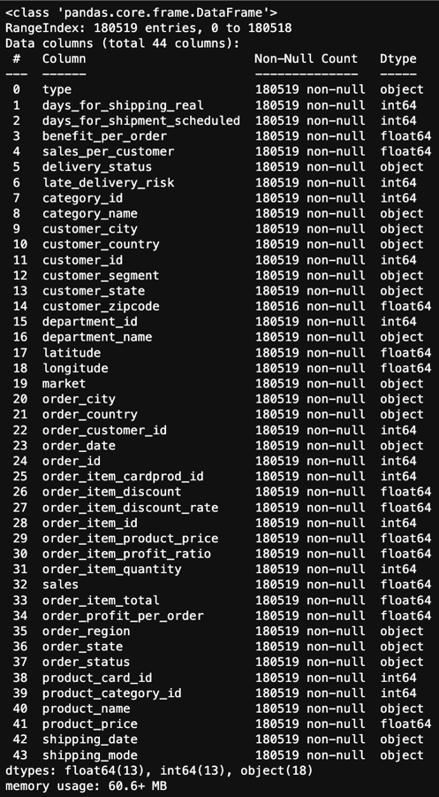problems with time, while running our models. The memory usage is only 60.6+mb which should not be a problem for my laptop, and everything is in one dataset showing no need to concatenate extra datasets.

In terms of cleaning most of the job is already done for me. There were no duplicates and no misspellings but some columns were in Spanish or used abbreviations, which unless told to do otherwise I thought it best to just leave as is, as maybe there were some unknown reason for having them in that format. In terms of data cleaning that I did do, is I deleted the 3 rows which contained null values in ‘customer_zipcode’, which made up less than % 0.00001 of the total data. I also renamed all the columns using snake convention (Leino, 2016) and dropped useless columns that mostly consisted of customer identifiers.

Figure 1: Info() method on df

Our target variable for Objective1 will be ‘late_delivery_risk’, which as mentioned before is a binary column; 0 = on time, 1 = is late. I will refer to this as our “Delivery Status” throughout our EDA section.

I used the following libraries and modules at various points throughout my project;

Pandas, Seaborn, NumPy, Matplotlib, Warnings, Plotly, Datetime, System, SciPy, Statsmodels, Scikit-learn, TensorFlow, Keras, Yellowbrick.

## Project management and planning

Based on the current objectives and what we learned from the data, I know that I will have to implement multiple machine learning models and machine learning techniques on a fairly large dataset while being limited to the tech that I have at my personal disposal within a limited timeframe.

To manage this project properly, I researched different project management methodologies and techniques and found that the Agile methodology as described in Advances in Computer (Zelkowitz, 2002), which focuses on flexibility and slow, building progress through it’s regular sprints to work best for my current circumstances and personal temperament. The timeline involved multiple sprints which spanned over the course of 2 months and 4 main blocks which I have broken down for you in the table 1 below, with a simplification of my 4 block timeline.

|  |
| --- |
| **Week 1-2**: Review of CA2 + Feedback, Brainstorm ideas, Project scope & Research |
| **Week 3-4**: Develop new models and try new EDA visualisations |
| **Week 5-6**: Test out model efficiency and compare with previous CA |
| **Week 7-8**: Finalise models, and prepare report and presentation |

Table 1: Project Timeline

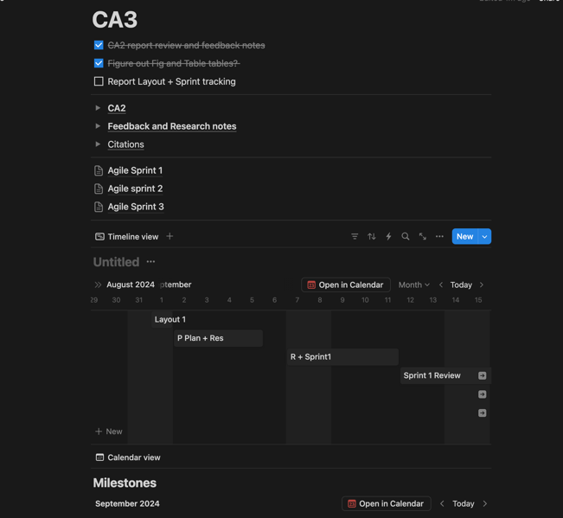

Figure 2: Notion dashboard of project

To make sure the project was going as planned and on time, I would monitor the progress with daily reviews of the previous work session. I would check in with the project goals, milestones and what I had gotten done/still had to do and kept track in the productivity and note-taking web app ‘Notion’ developed by Notion Labs as you can see in figure 2.

I think this plan and project management methodology was a comprehensive approach to the project’s objectives and addressed the limitations as well. It allowed systematic progress throughout each phase while still adapting to any challenges or changes in the project scope. The one thing I would change when using this methodology in the future would be to not underestimate the model run times, as each session had to be supervised and would eat up very valuable work time.

# EDA

## A graph showing a number of different colored squares Description automatically generatedTarget Distribution

To begin with the EDA for my data I started off by exploring my data with the profiling report command. After this I then continued by plotting out our target feature ‘late_delivery_risk’ with a count plot along with their corresponding percentages. As you can see from figure 3, late deliveries make up the majority feature with 54.8% of the counts. This shows that there is a slight imbalance but nothing major that most machine learning models can’t handle. I followed this up by then splitting my data into two new groups, numerical and categorical features.

Figure 3: Distribution of target feature

## Numerical Features

I then proceeded to analyse one of my new groups, my numerical features. I began by using a statistical summary (fig4), which showed me that there are a variety of insights with some outliers, both positive and negative skewness as well as some signs of normality, and features with different scales.

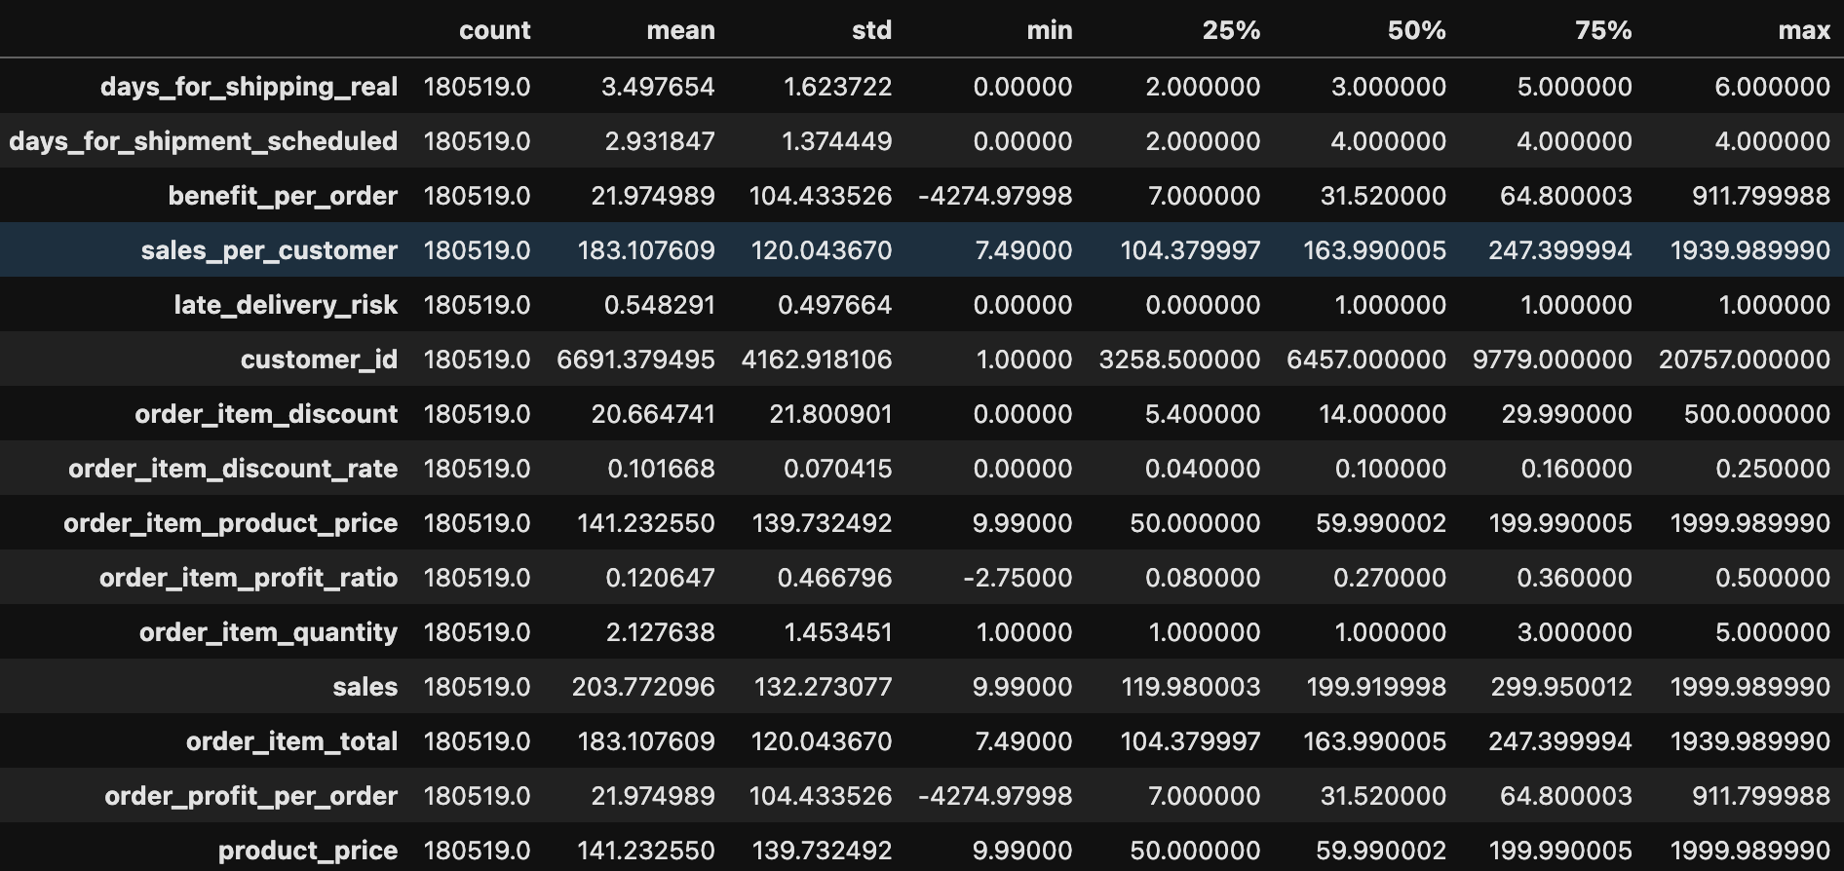

Figure 4: Statistical summary of Numerical Features

Figure 5 shows late vs on time delivery by how many days it took to deliver, showing some unexpected results. Days 3 and 4 performed the best relatively speaking, by having the smallest late to on time delivery ratio.

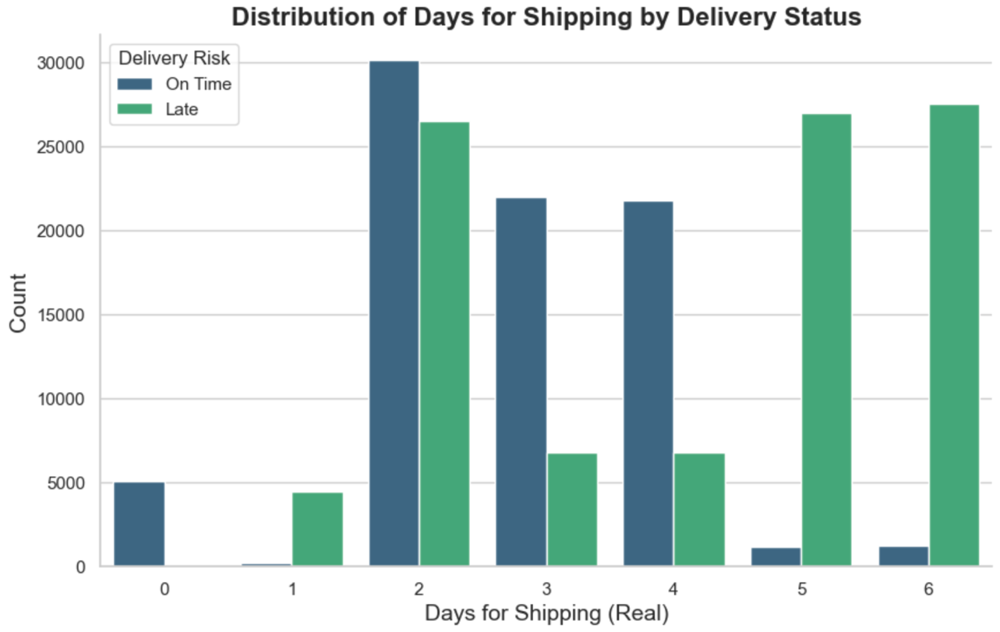

Figure 5: Distribution of Days for shipping by Delivery Status

Figure 6 shows the delivery status (late vs on time) by scheduled delivery time, which gives a little more context to fig 5, as well as showing that longer scheduled times (specifically 4 days) results in the highest amount of, and best ratio of on time deliveries.

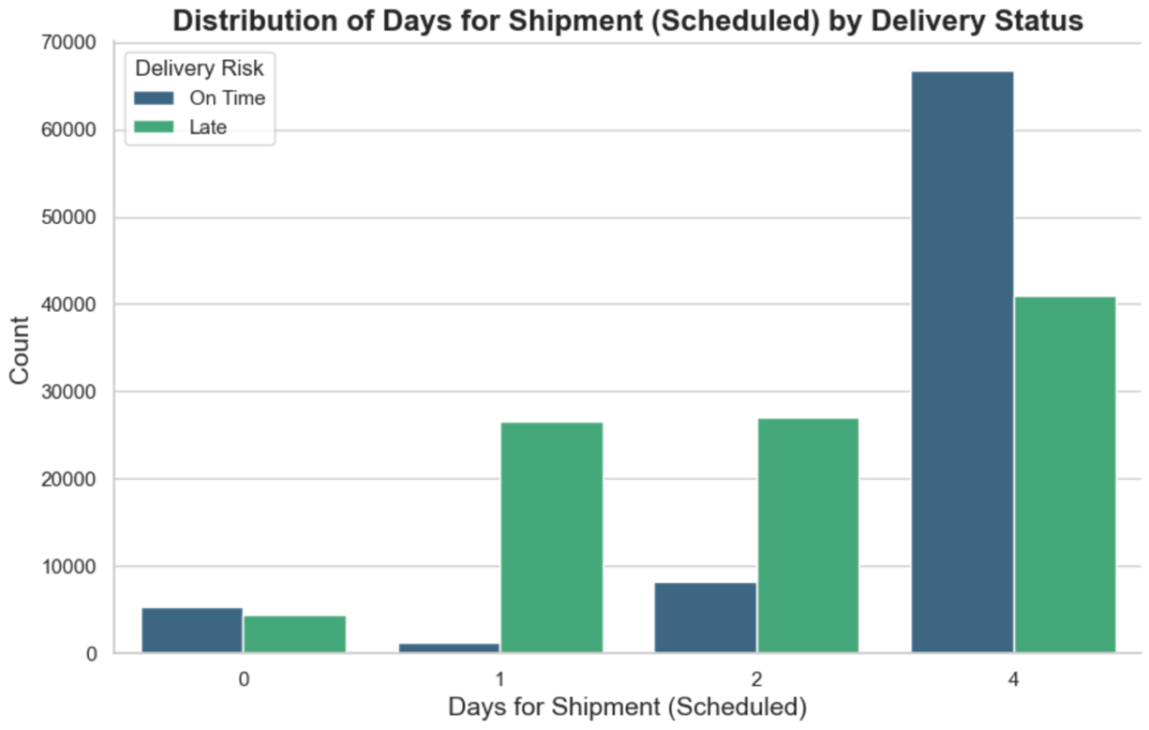

Figure 6: Distribution of days for shipment scheduled by Delivery Status

The following figures 7- 16 visualise delivery status by sales information, which show no clear indications of correlation, even for fig13 order quantity and fig 8 product price. I binned each one according to their scales for easier understanding.

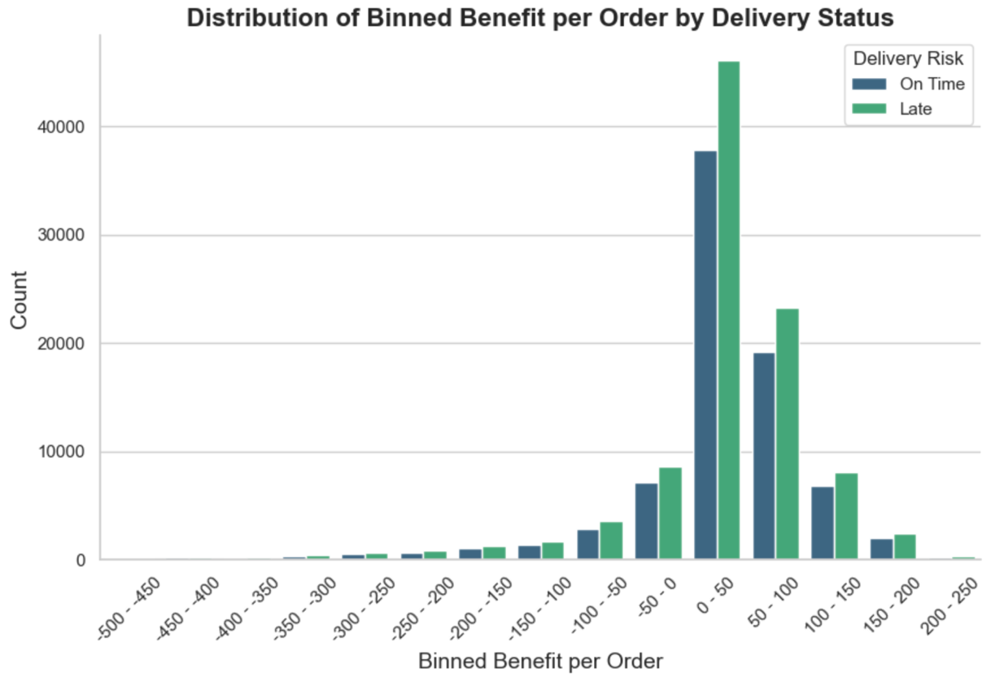

Figure 7: Distribution of Binned Benefit per Order by Delivery Status

In figure 7 we can see that most orders, whether delivered on time or late, have a benefit per order around the 0-50 range, so this could be a common profitability zone for deliveries. Late deliveries tend to be slightly more frequent than on-time deliveries in higher benefit ranges (50-100).

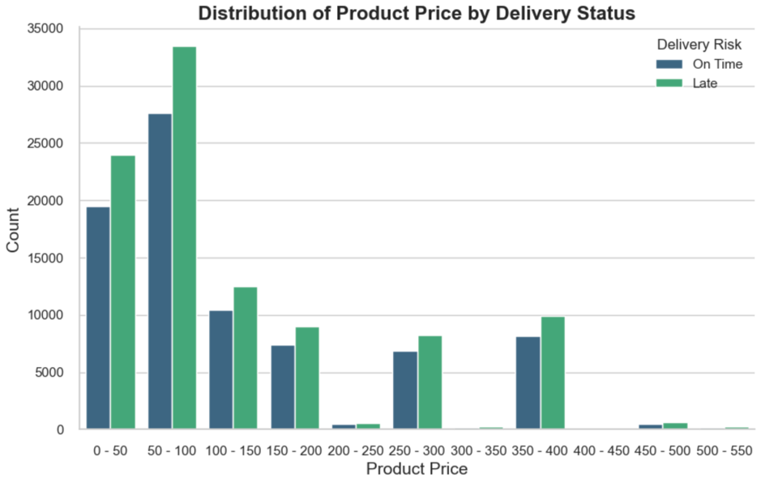

Figure 8: Distribution of Product Price by Delivery Status

In figure 8, products priced between 50-100 seem to be more likely to be delivered late, but again the ratio stays pretty much the same throughout most bins.

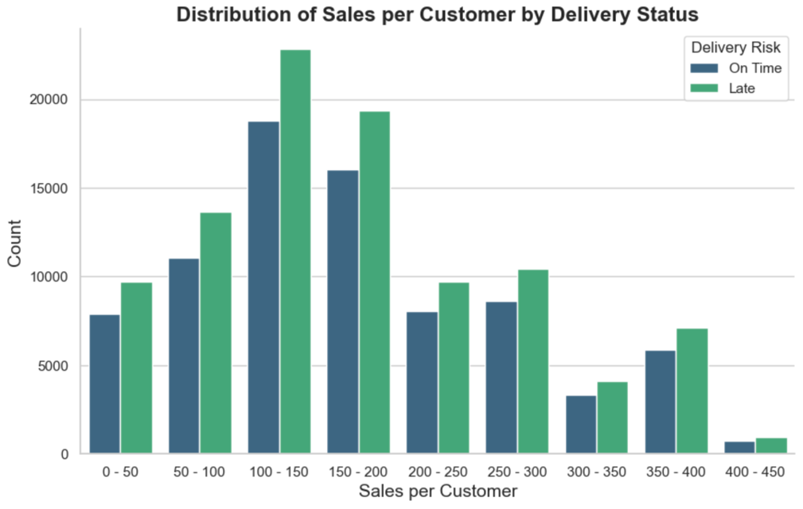

Figure 8.5: Distribution of Sales per Customer by Delivery Status

From figure 8.5 we can tell that customers in the range of 100-150 are more likely to experience late deliveries, as seen by the higher count of late deliveries compared to on-time deliveries in this range. But again, the ratio seems pretty consistent across most bins.

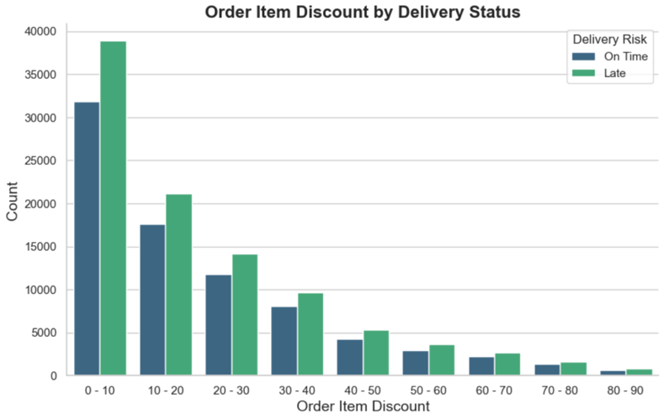

Figure 8: Order Item Discount by Delivery Status

From figure 9 we see most order discounts are around the lower ranges, and again, in terms of late deliveries the ratio seems pretty consistent throughout

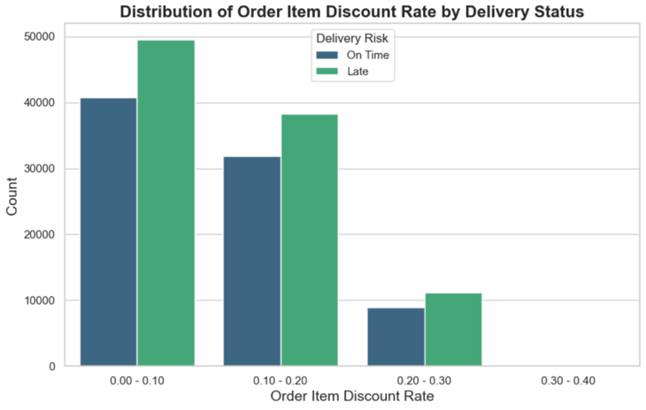

Figure 9: Distribution of Order Item Discount Rate by Delivery Status

As with the previous figure, the order item discount is almost solely focused around the lower ranges, but the ratio stays the same.

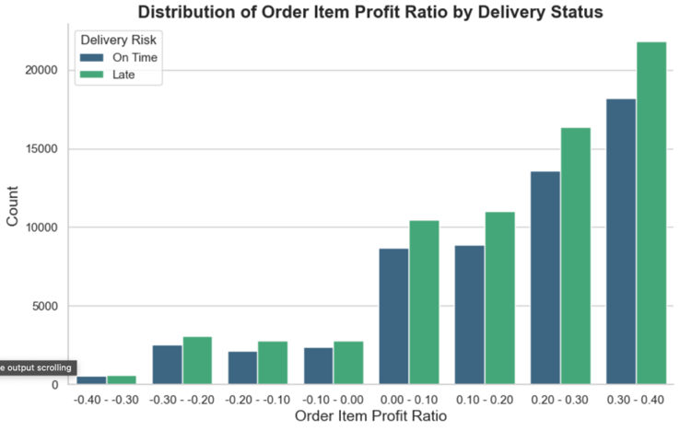

Figure 10: Distribution of Order Item Profit Ratio by Delivery Status

Order profit ratio too, shows no interesting correlation to the target variable. But we can see that most order items have a profit ratio >= 0.

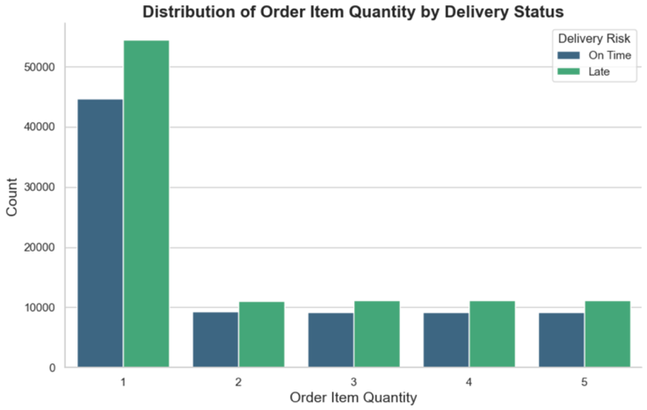

Figure 11: Distribution of Order Item Quantity by Delivery Status

From figure 11 we can see the same as before in regard to delivery status, but we also can tell that most orders are of 1 item in quantity.

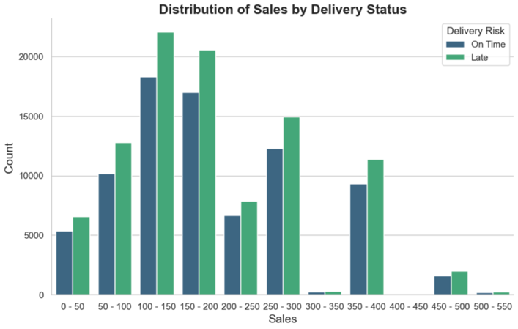

Figure 12: Distribution of Sales by Delivery Status

We see the ratio stay the same in fig 12, and a distribution showing that sales around 100-150 are most common in this dataset.

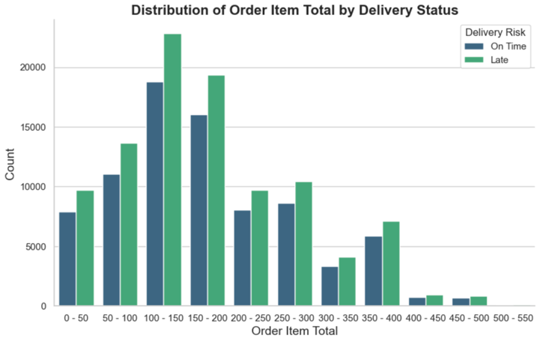

Figure 13: Distribution of Order Item Total by Delivery Status

Figure 13 depicting Order Item Total, had near the exact same results from figure 13 except for bins 200-250, and 300-350.

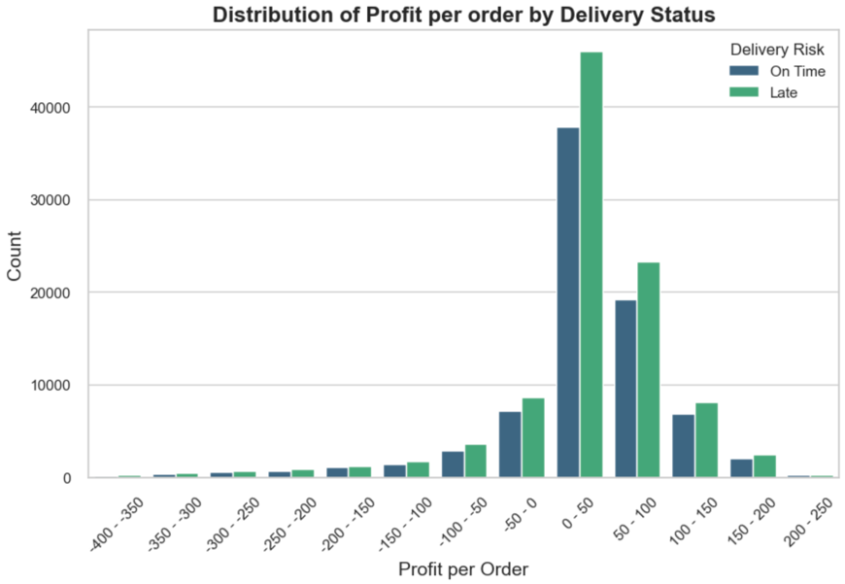

Figure 14: Distribution of Profit per order by Delivery Status

Figure 14 shows the same ratio as before but we also see that profits of 0-50 are the most common.

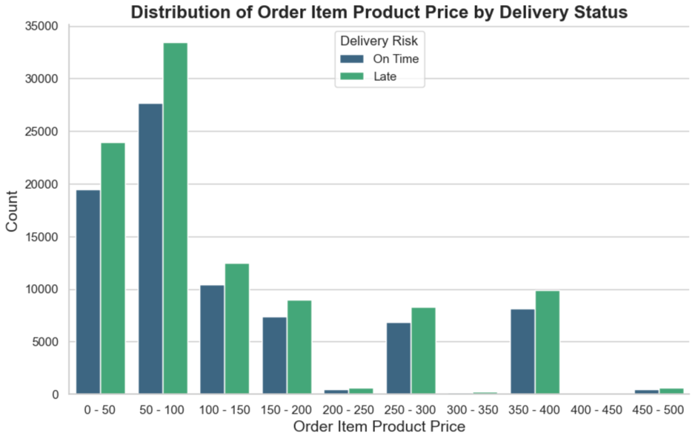

Figure 15: Distribution of Order Item Product Price by Delivery Status

Finally figure 15 shows no real insights on delivery status for order item product price, by it does show that the two most common bins of order item product price are 0-50 and 50-100

## Categorical Features

I began my exploration of my categorical features (fig16) with a statistical description, which even on it’s own shows some interesting insights, including top product category, top cities, top departments etc.

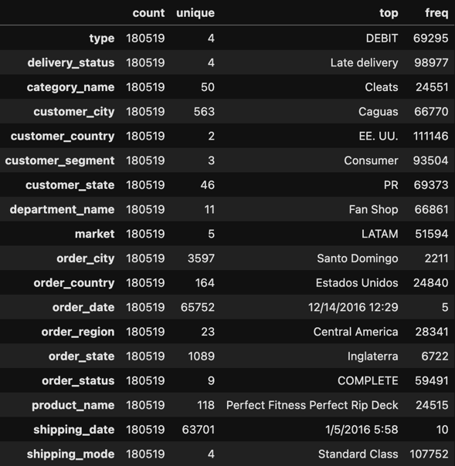

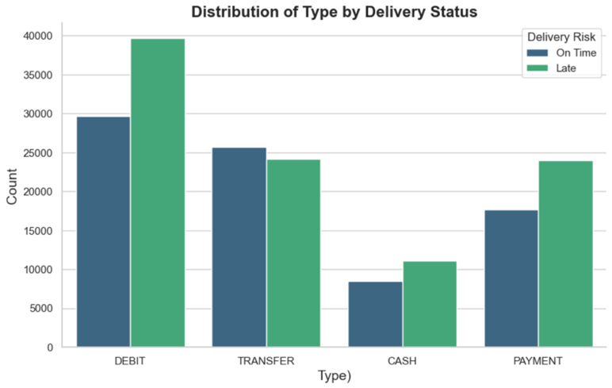Figure 16: Statistical description of Categorical Features

Figure 17 shows no clear relationship between payment types and delivery status. Figure 18 shows the rather unintuitive result of Standard Class having the highest count of on time deliveries and First class having the worst ratio.

Figure 17: Distribution of Type by Delivery Status

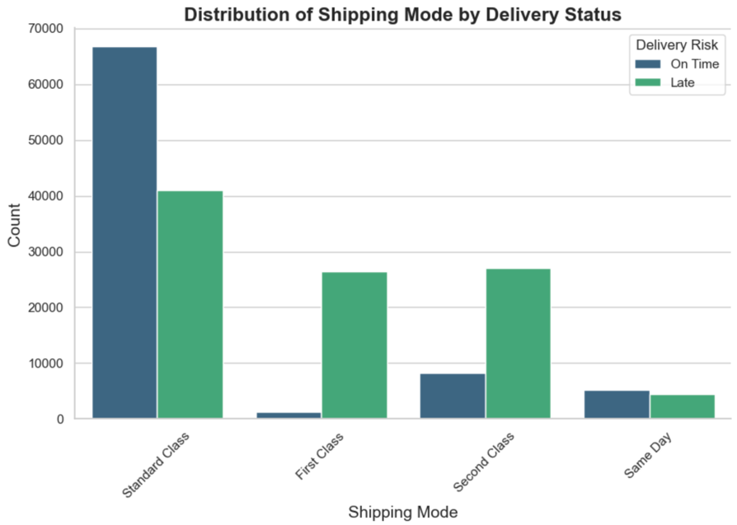

Figure 18: Distribution of Mode by Delivery Status

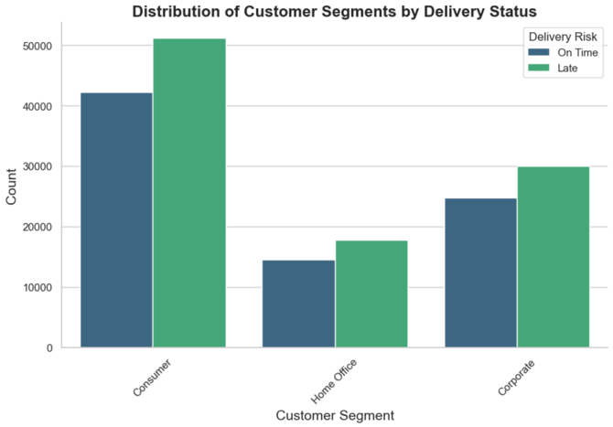

We can see pretty much the same while looking at customer segment in figure 19 and by the order status in figure 20, with them both having no clear relationship with the delivery status.

Figure 19: Distribution of Customer Segment by Delivery Status

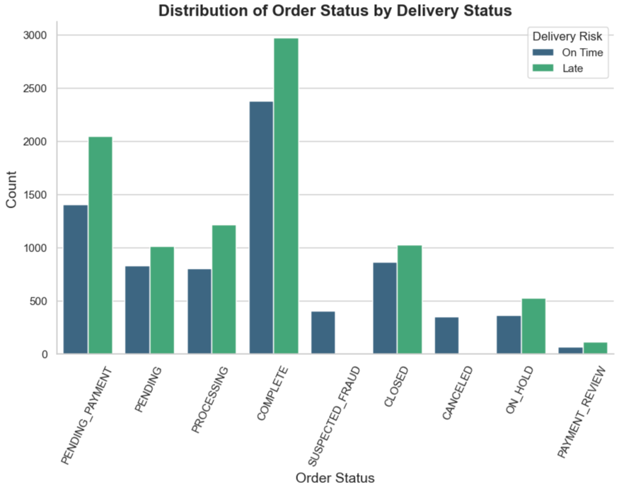

Figure 20: Distribution of Order Status by Delivery Status

From figures 21, 21.5 and 22 we can see the same as before of no clear relationships between the product, it’s categories nor departments with the delivery status.

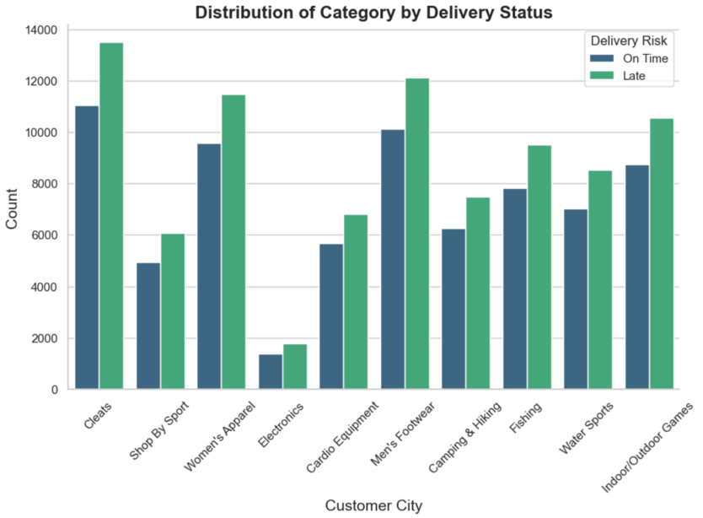

Figure 21: Distribution of Category by Delivery Status

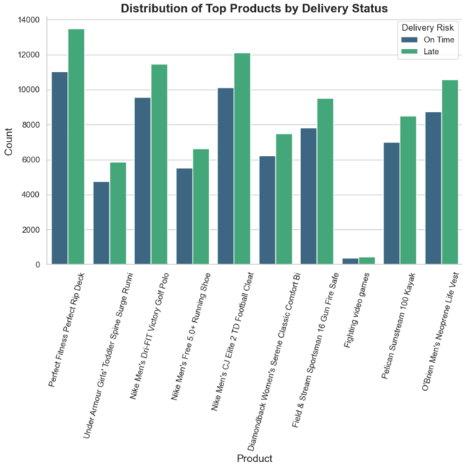

Figure 21.5: Distribution of Top products by Delivery Status

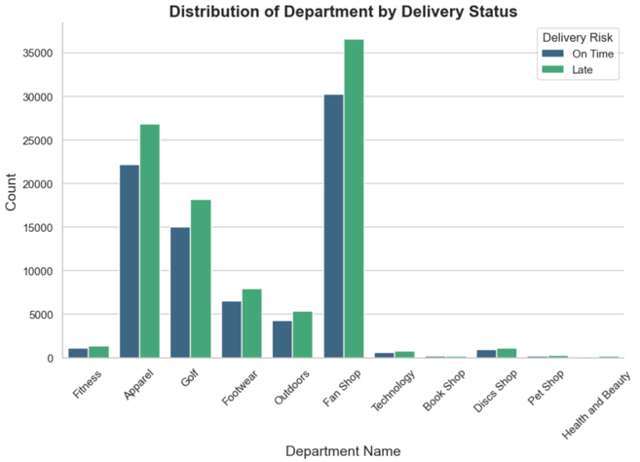

Figure 22: Distribution of Department by Delivery Status

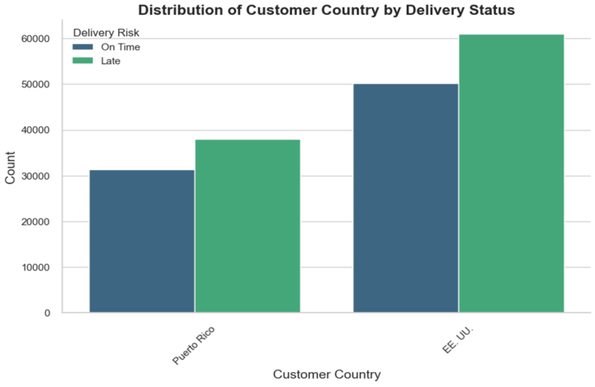From the following figures 23-30 we can see the distribution of delivery status by some of the geographical features in the dataset. The same pattern of the previous figures emerges, of no real differences except for slightly higher rates of late deliveries in New York City, Caguas and Santa Domingo.

Figure 23: Distribution of Customer Country by Delivery Status

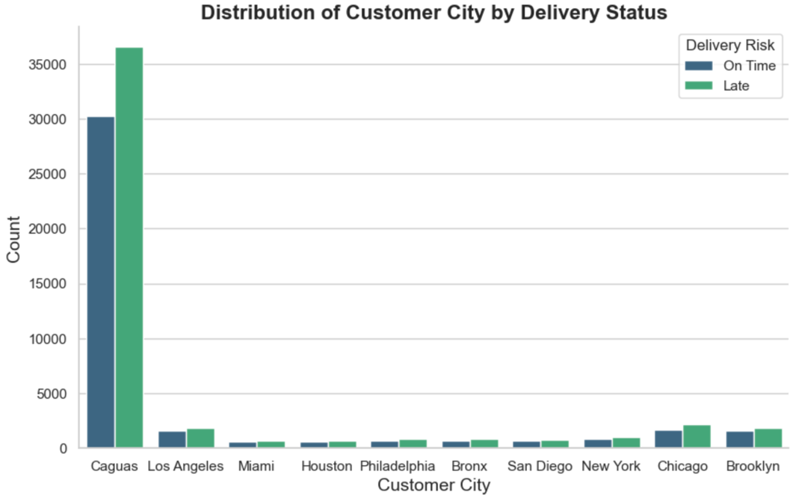

Figure 24: Distribution of Customer City by Delivery Status

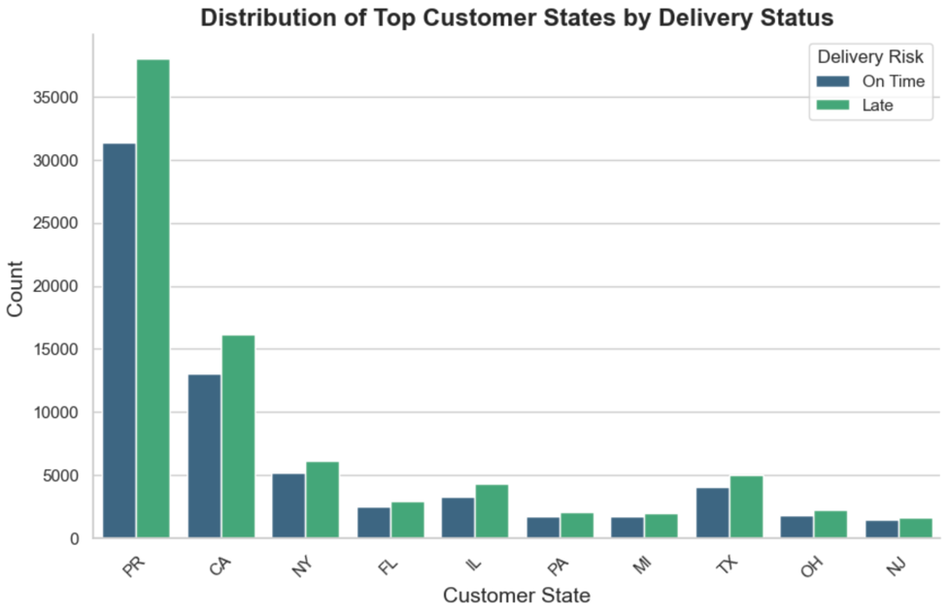

Figure 25: Distribution of Customer State by Delivery Status

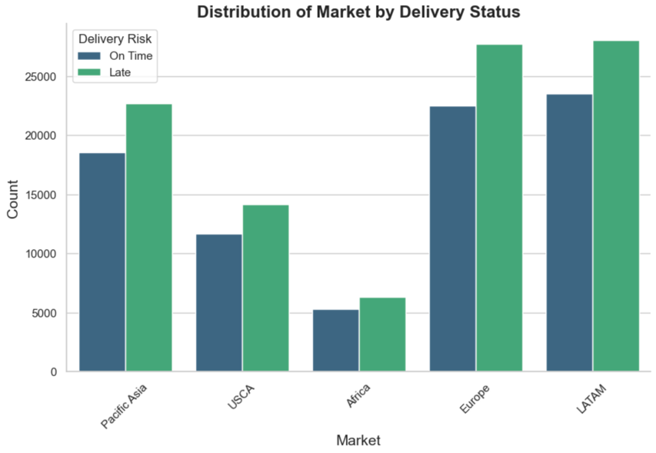

Figure 26: Distribution of Market by Delivery Status

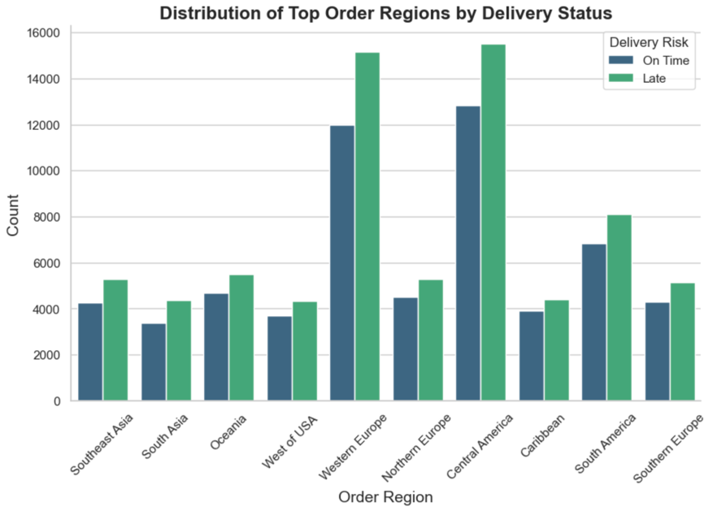

Figure 27: Distribution of Top Order Regions by Delivery Status

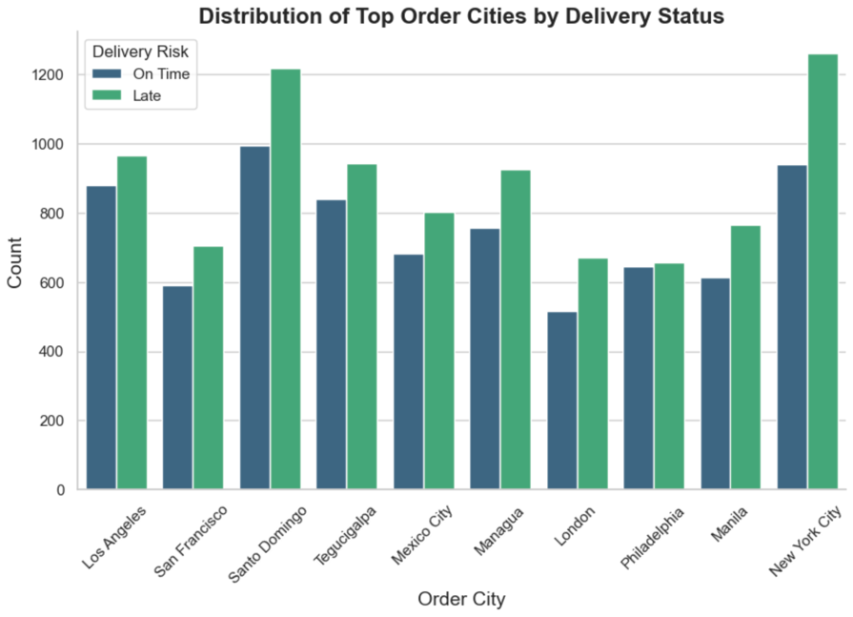

Figure 28: Distribution of Top Order Cities by Delivery Status

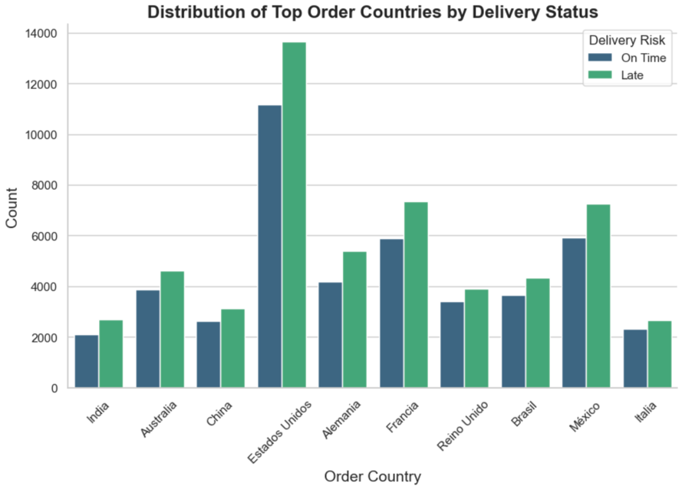

Figure 29: Distribution of Top Order Countries by Delivery Status

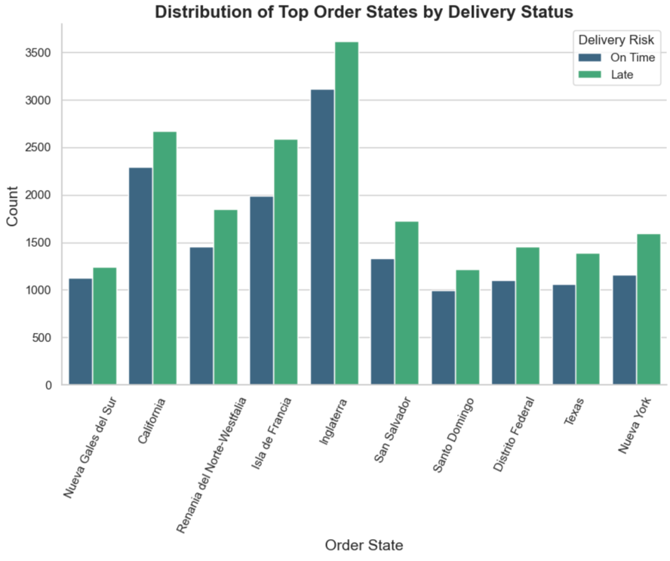

Figure 30: Distribution of Top Order States by Delivery Status

## Geographical

Since geographical features are such a huge component to supply chain issues (Chopra and Meindl, 2019) I decided to plot 2 maps using MapBox to better visualise the geographical distribution of delivery status across the globe. I had to create an account to get an access token before creating 2 live and interactive “open-street-map” style maps which showed either late deliveries only (*fig 31)* or late deliveries vs on time deliveries(*fig 32)* across the globe. I have included just the US below for simplicities sake, but you can explore more countries with the interactive map in the corresponding notebook.

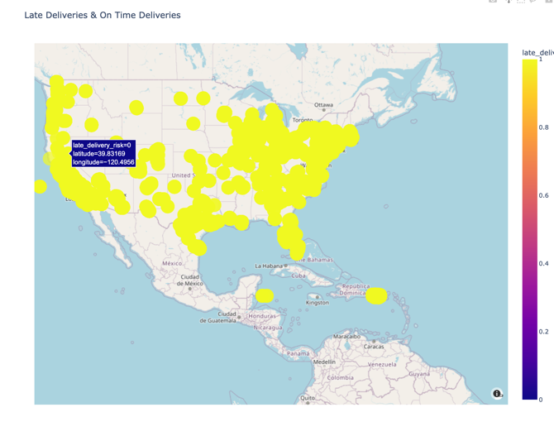

Figure 31: Late Deliveries map of US

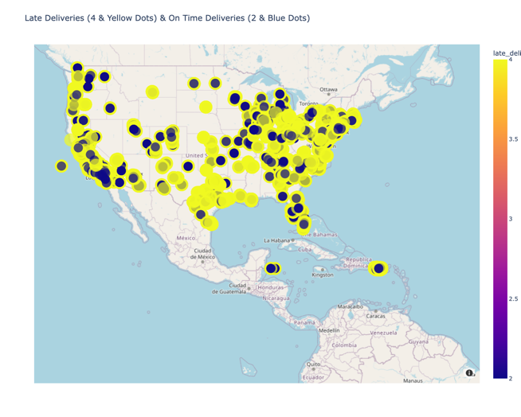

Figure 32: Late vs On Time Deliveries Map of US

## Time series

In figures 33 we can see a time series plot of the count of late deliveries over the full timeline of the dataset, which shows some possible indications of seasonality. If more time was available I think conducting and ADF test for stationarity, acf and pacf for seasonality and an autoarima to find the best order, to just see if a box Jenkins model were able to fit the data, could lead to some very useful insights for the company.

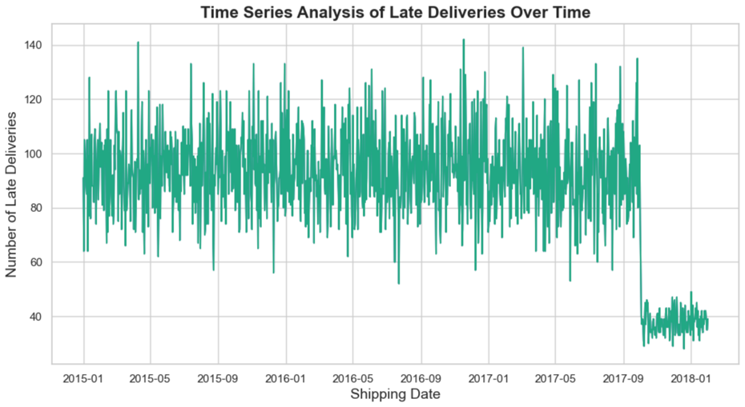

Figure 33: Time Series Plot of Late Deliveries

I then just plotted the same time series plots but for each year in figures 34-36.

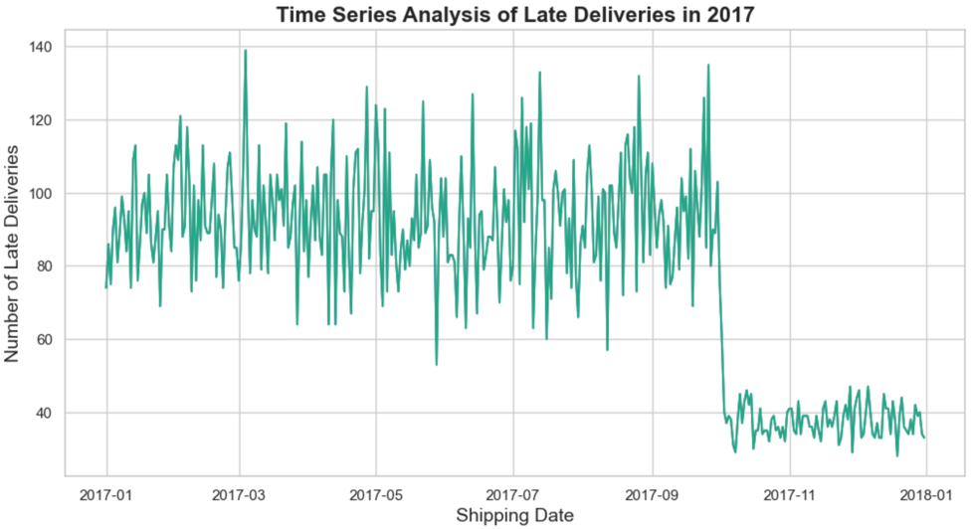

Figure 34: Time Series Plot of 2017

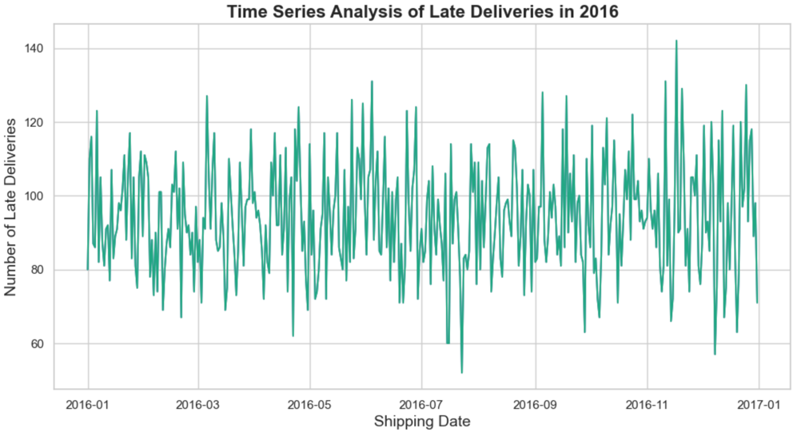

Figure 35: Time Series Plot of 2016

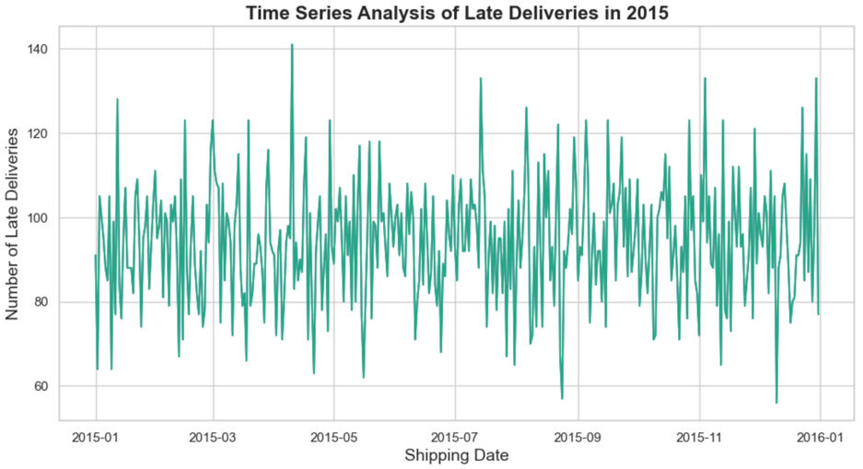

Figure 36: Time series plot of 2015

For a slightly easier to read visual of the total performance by time frames, I started by year where I created a bar plot of the late deliveries to on time deliveries by year with an overlayed line plot (fig38). I then did the same by quarter, week and hour in figures 37-39. An interesting trend is the slow increase in average on time deliveries after midday and downward trend in late deliveries at the same time.

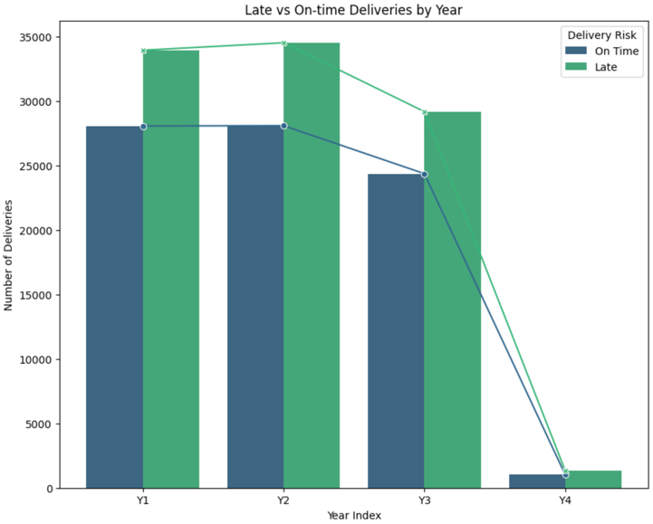

Figure 37: Late vs On time Delivery by Year

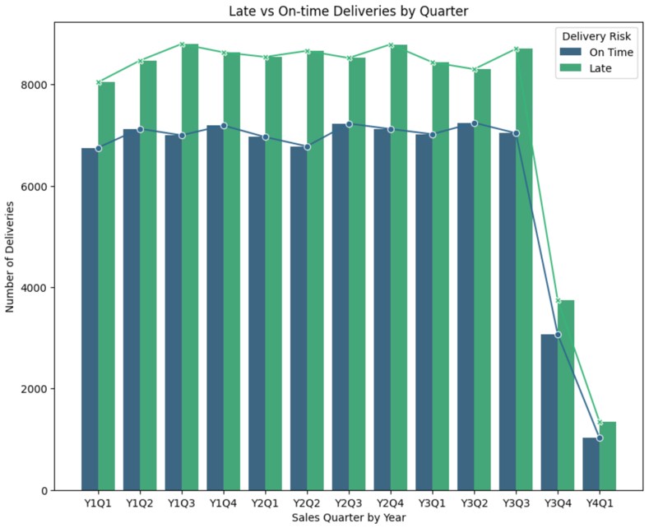

Figure 38: Late vs On time Delivery by Quarter

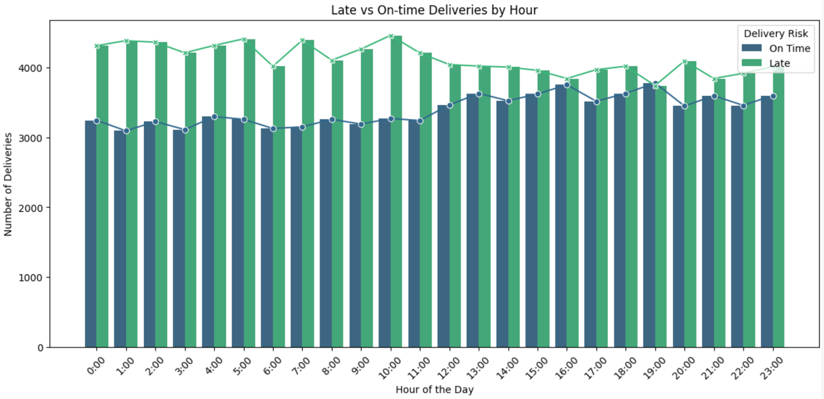

Figure 39: Late vs On time Deliveries by Hour

## A screenshot of a computer screen Description automatically generatedCorrelation

Figure 40: corr() method on df

I began my correlation analysis with the .corr() method and made sure that it sorted into descending order. You can see straight away figure 40 there are not very many strong correlations with our target variable, and there will be some possible issues with data leakage from some of the higher end correlators.

I then visualised this data with a correlation matrix (fig41), removing late_delivery_risk as it just dwarved the other features in the plot. I also changed the palette from viridis to set1 as although it breaks the theme, set1 makes it much easier to distinguish the features.

I also plotted the data with a heatmap (fig42) which is a much better showcase of the data and of the correlations between each of the features.

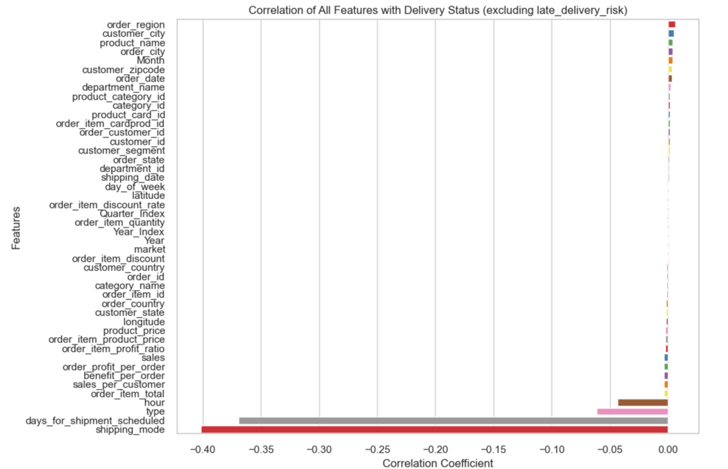

Figure 41: Correlation of features with Delivery Status

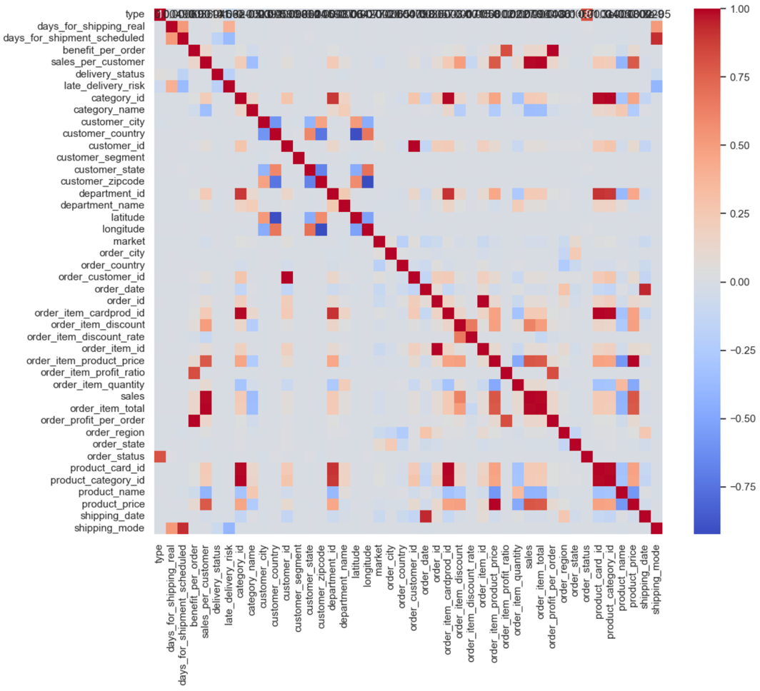

Figure 42: Heatmap of correlation matrix

## Dashboard

I created three animated figures to show sales, profit, and late delivery (fig43). I started off with the three choropleth maps using plotly to show sales, profit per order, and the proportion of late deliveries by state over increments of months and I used colour scales to show the values. I then went onto built a Dash app with a more modern layout, organised the sales and profit graphs together, and then put the target feature which is the late deliveries graph at the bottom on it’s own. Then I ran the app with some styling for more easy interpretation which was heavily inspired by (W3schools.com). I used a lot of standard styling with arial and sans serif fonts and I have also added in comments in the code to show what I did throughout. I also had to conduct IQR on my benefit_per_order column for the sake of clarity in the visualisation process.

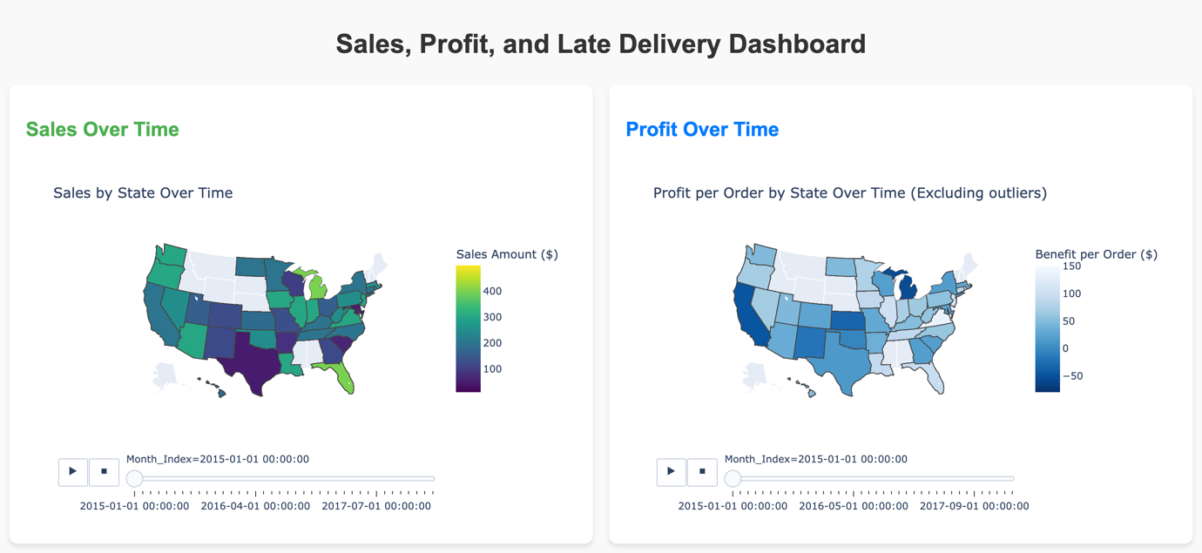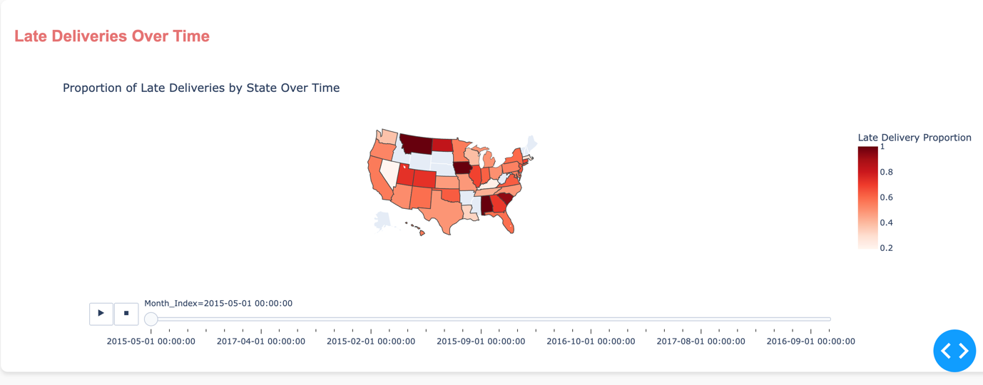

Figure 43: Sales, Profit and Late Delivery Dashboard

# ML

## Objective 1 - Classifier

To address Objective 1 which was to use machine learning techniques to predict late deliveries, I decided to use a supervised classification model for predicting our target variable. In this section I will go over my model selection process and then the top three models chosen from that process, with their param tunings, cross fold validation and finally then I will explore the interpretability of that model. I have tried to test these models on 1%, 5%, 10%, 25%, 50% ,75% and 100% of the data and found the 5th option of 50% to be the best balance between results and time/tech constraints, so each of the following supervised models will be run on 50% of the data, but I will use a consistent seed throughout so the experiments can be reproduced. The bench marks, as previously stated, for success will be if I can improve upon the results from my CA2 which you can see in figure 44.

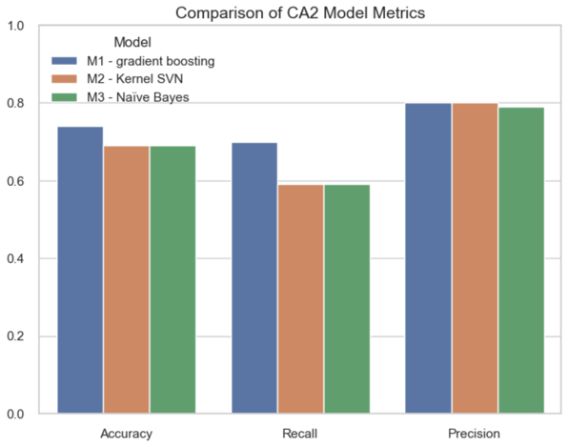

Figure 44: Comparison of CA2 Model Metrics

Since our target feature is binary, this will be a classification issue and during one of my previous exploratory research sessions I have found a new technique to run multiple tests on default parameters of multiple models at the same time, testing accuracy, recall, precision, F1 and ‘area under curve’(AUC) (Desalegn, 2023). The models I used were Nearest Neighbors, Support Vectors, Decision Tree, Random Forest, AdaBoost, XGradient Boosting, Naive Bayes, Quadratic DA and Neural Net.

I got the following results:

|  |  |  |  |  |  |
| --- | --- | --- | --- | --- | --- |
| **Classifier** | **Accuracy** | **Recall** | **Precision** | **F1** | **ROC_AUC** |
| **Decision Tree** | 0.761932 | 0.727142 | 0.823604 | 0.772373 | 0.766273 |
| **Random Forest** | 0.752493 | 0.674725 | 0.84867 | 0.751767 | 0.851244 |
| **Nearest Neighbours** | 0.701706 | 0.560874 | 0.851399 | 0.676254 | 0.774921 |
| **Gradient Boosting** | 0.667051 | 0.486596 | 0.849798 | 0.618842 | 0.730039 |
| **AdaBoost** | 0.643696 | 0.428834 | 0.859175 | 0.572113 | 0.676973 |
| **Quadratic DA** | 0.59322 | 0.543641 | 0.663292 | 0.597536 | 0.647057 |
| **Neural Net** | 0.567826 | 0.948939 | 0.566219 | 0.709243 | 0.570356 |
| **Support Vectors** | 0.555462 | 1.0 | 0.555462 | 0.714208 | 0.520173 |

Table 2: Classifier Results

As you can see from table 2 the top three classifiers are decision tree, random forest and KNN. Since Random Forests are just an ensemble of decision trees, and they more often provide more robust and generalized predictions by combining the results of multiple trees which reduce the overall risk of overfitting (Breiman, 2001), I decided to keep random forest and to scrap decision trees in favour of the next best model which was Gradient Boosting. I then decided after more research that I should swap out gradient boosting for the faster and more flexible XGBoost model (Bentéjac et al., 2020).

|  |  |  |  |  |  |
| --- | --- | --- | --- | --- | --- |
| **Classifier** | **Accuracy** | **Recall** | **Precision** | **F1** | **ROC_AUC** |
| **Random Forest** | 0.752493 | 0.674725 | 0.84867 | 0.751767 | 0.851244 |
| **Nearest Neighbours** | 0.701706 | 0.560874 | 0.851399 | 0.676254 | 0.774921 |
| **Gradient Boosting** | 0.667051 | 0.486596 | 0.849798 | 0.618842 | 0.730039 |

Table 3: Chosen top three models

When tuning these 3 chosen models (table 3) in the next section, the objective will be to find a better balance between precision and recall, mainly improving recall as the business objective is to identify late deliveries. Missing late deliveries, with a lower recall, could be critical for the supply chain, leading to potential business risks but falsely predicting a delivery as potentially late is way less harmful than missing a real late delivery. It’s always better to err on the side of caution by identifying potential late deliveries (AKA the recall), even if a few on-time deliveries are incorrectly flagged.

In my CA2 I heavily relied on “Introduction to machine learning” by Müller & Guido, which led me to choose Naïve bayes, Kernel SVM and Gradient boosted classifier (Müller, 2016). I think my new models are more optimised for slightly more accurate predictions of late deliveries.

## M1

For my First model which is a random forest model I decided to go with the following parameters in table 4.

|  |  |
| --- | --- |
| n_estimators | 100, 300 |
| max_depth | 10, 20, 30 |
| min_samples_split | 2, 10 |
| min_samples_leaf | 1, 5 |
| criterion | Gini, Entropy |

Table 4: Random Forest Grid Search Parameters

Although in an ideal scenario with not so many limitations or in future experiments I would suggest the params in table 5 (Scikit-learnRF, 2024).

|  |  |
| --- | --- |
| n_estimators | 100, 200, 300, 500 |
| max_depth | 3, 5, 15, 10, 20, none |
| min_samples_split | 2, 5, 10, 15 |
| min_samples_leaf | 1, 2, 5, 10 |
| criterion | Gini, entropy |

Table 5: Future Random Forest Parameters

The classification report in figure 45 and table 6 shows the best parameters chosen by the grid search. As we can see, it suffered from overfitting with training accuracy returning 99% and test accuracy only returning 74%. So, in an attempt to fix that I changed the parameters to those in table 7 and figure 46.

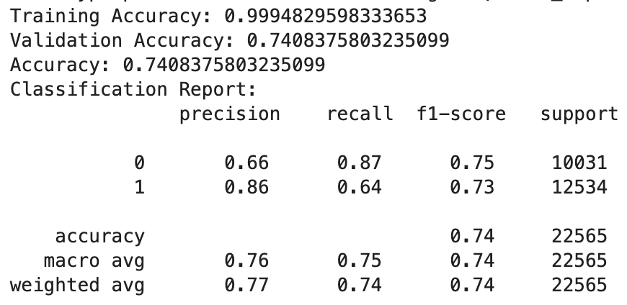

Figure 45: Random Forest Model Results

|  |  |
| --- | --- |
| n_estimators | 300 |
| max_depth | 30 |
| min_samples_split | 2 |
| min_samples_leaf | 1 |
| criterion | Gini |

Table 6: Random Forest Best Parameters

Random Forest model’s accuracy score dropped by 5% with the grid search applied, improved it’s precision by 2% but actually lost 9% in it’s recall, which is the prioritised metric. The cross validation with five folds shows a reasonable and consistent performance. This is an overall poor model, or at least the choice of parameters to solve the current objective are, and is only better than 2 out of the three models in my CA2 in terms of recall.

|  |  |
| --- | --- |
| n_estimators | 200 |
| max_depth | 15 |
| min_samples_split | 10 |
| min_samples_leaf | 4 |
| criterion | Gini |

Table 7: Random Forest with new parameters

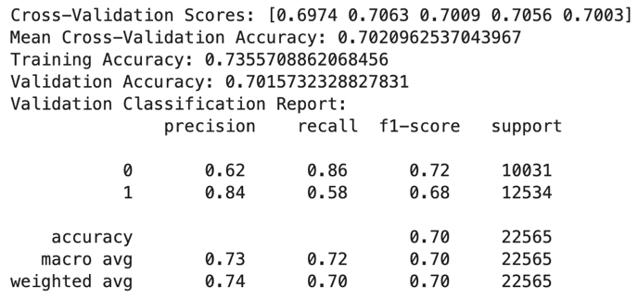

Figure 46: Random Forest with new parameters Classification Report

## M2

My second model that I chose was a KNN model, with the parameters used in the model in table 8. Alternatively, I also have put my preferred parameters in table 9 for future experimentation (Scikit-learnKNN, 2024), and I would also recommend feature scaling, as the KNN can be quite sensitive to it.

|  |  |
| --- | --- |
| N_neighbours | 5, 10, 20 |
| Weights | uniform, distance |
| Algorithm | Auto, ball tree |
| Leaf size | 30, 40 |
| p | 1, 2 |

Table 8: KNN Parameters

|  |  |
| --- | --- |
| N_neighbours | 3, 5, 10, 15, 20, 25 |
| Weights | uniform, distance |
| Algorithm | Auto, Ball Tree, kd_tree, Brute |
| Leaf size | 20, 30, 40, 50, 60 |
| p | 1, 2, 3 |

Table 9: Future KNN Parameters

The classification report in figure 47 and table 10 shows the best parameters chosen by the grid search.

|  |  |
| --- | --- |
| N_neighbours | 5 |
| Weights | distance |
| Algorithm | Auto |
| Leaf size | 30 |
| p | 1 |

Table 10: KNN Best parameters with overfitting (Test 1)

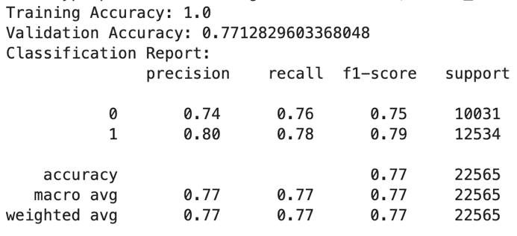

Figure 47: KNN Best Result with overfitting (Test 1)

As we can see the KNN model performed very well but suffered from massive over fitting, scoring 100% on the training data and 77% on the test data. I adjusted the parameters to the ones in table 11 and was able to improve the over fitting issue but not completely, with there still being a 11% gap in the training and testing data. The accuracy in the params that improved over fitting has lost 9% in accuracy and 13% in precision and lost 1% in recall from the model selection results in the beginning. The low range and close clustering around 0.59 suggests that the KNN model has small predictive power and struggles to be consistent across different data splits. Overall this is a very poor model and performed the worst out of all the models in both CA2 and CA3.

|  |  |
| --- | --- |
| N_neighbours | 8 |
| Weights | uniform |
| Algorithm | Auto |
| Leaf size | 30 |
| p | 2 |

Table 11: KNN Best parameters (Test 2)

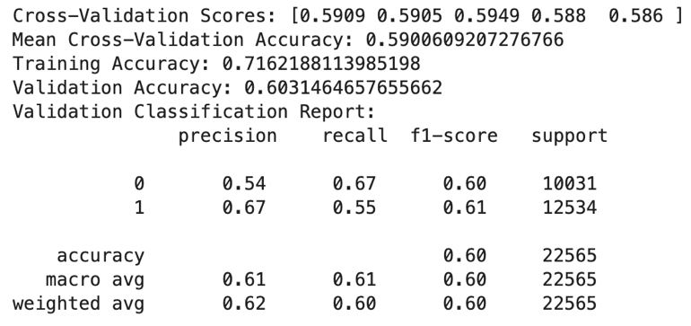

Figure 48: KNN Best Results (Test 2)

## M3

My Final model was an XGBoost model, with the parameters used in the model in table 12. I am pretty happy with these parameters but possible experimentation with gamma , child_weight or reg_lambda in the future could have some interesting results (Scikit-learnXGB, 2024). The classification report in figure 49 and table 13 shows the best parameters chosen by the grid search.

|  |  |
| --- | --- |
| n_estimators | 100, 300, 500 |
| Max Depth | 3, 5, 7, 9 |
| Learning Rate | 0.01, 0.05, 0.1 |
| Sub Sample | 0.7, 0.8, 1.0 |
| colsample_bytree | 0.7, 0.8, 1.0 |

Table 12: XGBoost Parameters

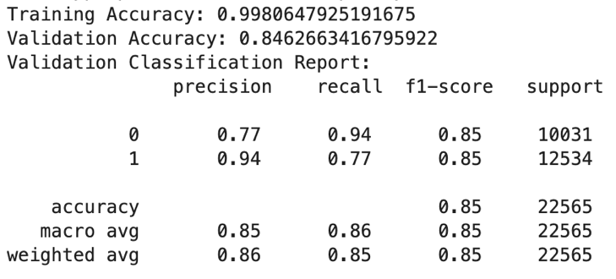

Figure 49: XGBoost Best Result

|  |  |
| --- | --- |
| n_estimators | 500 |
| Max Depth | 9 |
| Learning Rate | 0.1 |
| Sub Sample | 1.0 |
| colsample_bytree | 1.0 |

Table 13: XGBoost Best Parameters (Test 1)

We see some slight over fitting with the train data at 99% and test data getting 84%, so I adjusted the parameters to the ones seen in table 14, improving the overfitting and getting the best results so far. With improvements of 16% in accuracy, 26% in recall and 8% in precision from the model selection phase, this model not only beats the other two models in all metrics in this CA3, but it also beats all models in the CA2 as well.

|  |  |
| --- | --- |
| n_estimators | 300 |
| Max Depth | 8 |
| Learning Rate | 0.1 |
| Sub Sample | 1.0 |
| colsample_bytree | 1.0 |

Table 14: XGBoost Best parameters with improved overfitting (Test 2)

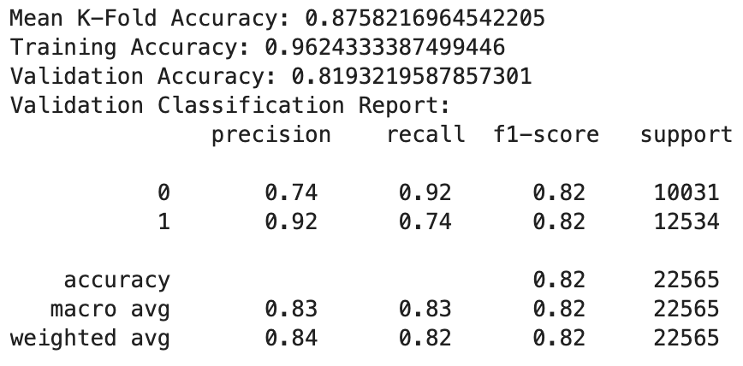

Figure 50: XGBoost Best results with improved overfitting (Test 2)

## XGBoost Model

The XGBoost model performed quite well with consistent results through the k-fold Cross validation through 5 folds and the holdout val set (fig51) (Scikit-learnCV, 2023).

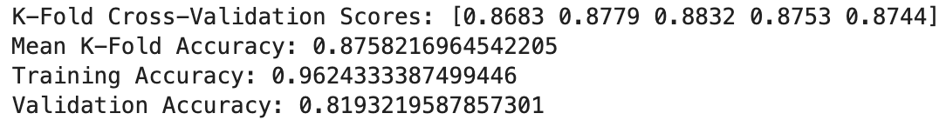

Figure 51: K-fold Validation on XGBoost

I decided to explore my model further with the built in feature importance and found some very interesting results (Brownlee, 2019). I plotted the top most important features by weight (Aka Frequency) and by gain in figures 52 and 53. The results showed shipping mode and days for shipment scheduled are the most important features, both frequently used and important in improving the model’s accuracy. Although less impactful I found order data, and shipping date to be surprising to appear here, and could indicate that future time series analysis could be useful.

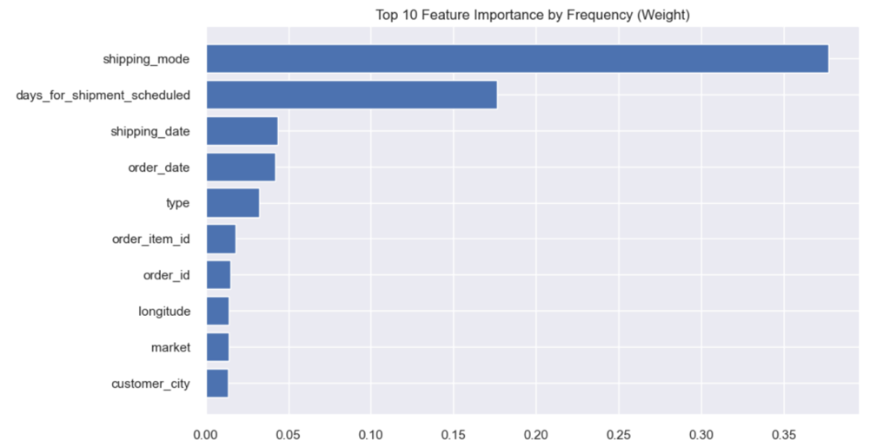

Figure 52: Top 10 Feature Importance by Weight

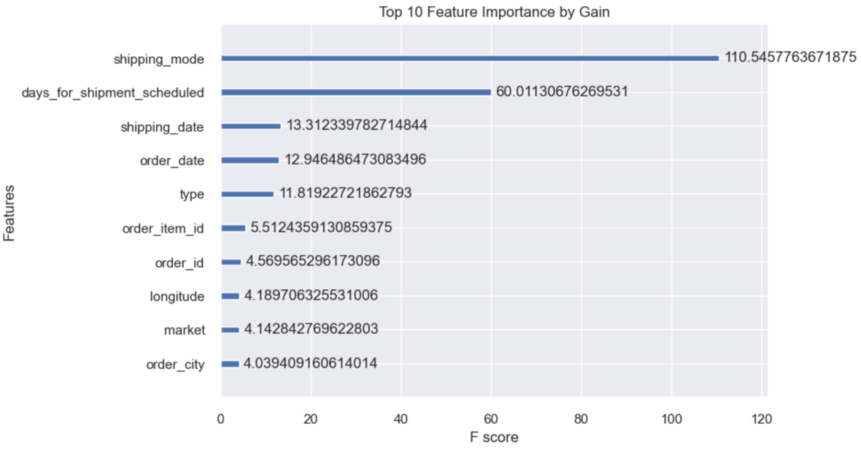

Figure 53: Top ten Feature Importance by Gain

In order to get a feel for the individual features I also decided to use LIME to see how some of the features are influencing the model during a random incident, which could possibly then be used for real world insights. I had to first reverse the label encoded categorical features, to read the LIME visuals, (Scikit-learnLE, 2023). We can then see in figure 54 some insights for a random incident, some of these were known from the EDA but some were completely new.

From it you could know that if;

* you schedule the delivery for 2 days or longer you reduce the likely hood of being late.
* If the order date was on or before 5/20/2017 8:56 the delivery is more likely to be late.
* If the shipping date was on or after 5/28/2016 11:22 the delivery is more likely to be late.
* If it was shipped standard class, it was less likely to be late.
* If the payment type was a transfer, it was more likely to arrive late.

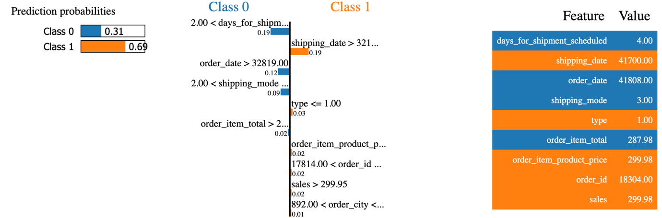

Figure 54: LIME tool results

## Clustering

## Introduction

For my second objective which was to “identify distinct customer segments and explore their characteristic”, I decided to cluster my data with a k means model, which is an unsupervised machine learning technique (Sinaga & Yang, 2020). A potential issue that this dataset could face is the curse of dimensionality, due to it’s large size and multiple features. To get around this issue I decided to use a dimensionality reduction technique called principal component analysis (PCA) (Jolliffe & Cadima, 2016). After which I would use the elbow method to find the optimal number for K and then run my K means model. I will also run silhouette tests to make sure we have a quantifiable result for how well the clustering of the data went (Ogbuabor & F. N, 2018). This would be followed by cluster analysis and some simple EDA of the results.

## PCA + Elbow method

I started off by removing the target column "late_delivery_risk" from my df, to focus only on the features. Then, I use Standard scaler to scale these features, so they have a mean of zero and a standard deviation of one. Next, I applied PCA to reduce the dataset’s dimensions to 3 principal components, capturing the most important variance in the data. I then store the transformed data in a new DataFrame and used .describe().T to get a summary (fig55). The output shows that each principal component has a mean close to zero, confirming the scaling, with varying spreads and ranges that indicate how the data’s structure is captured in these new dimensions.PCA is an unsupervised method that reduces dimensionality by maximizing the variance captured in a dataset (Chandra, 2013).

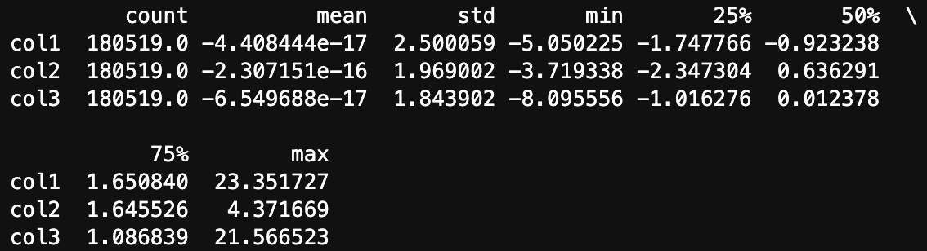

Figure 55: Statistical summary of PCA

I then decided to visualise the three components in a 3 dimensional space with an interactive plot of the reduced dimension (fig 56). I then used the KElbowVisualizer from the yellowbrick library to use the Elbow Method for finding the best number of clusters in my df. I initialized the visualizer with KMeans, and set the random_state=0 so if you want to recreate the project you can, and specified a range of up to 10 clusters (k=10). I then fit it to my PCA-transformed dataset (PCA_ds) and displayed the plot to find the point where adding more clusters no longer improves the model (elbow point) (fig 57).

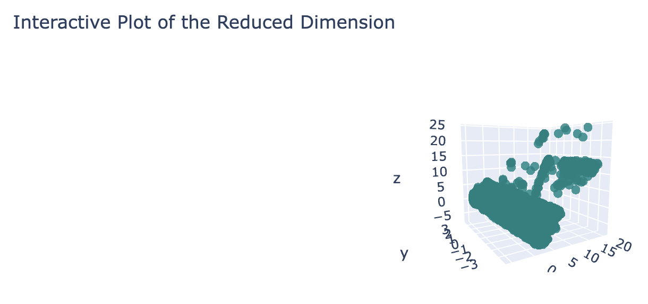

Figure 56: Interactive Plot of The Reduced Dimension

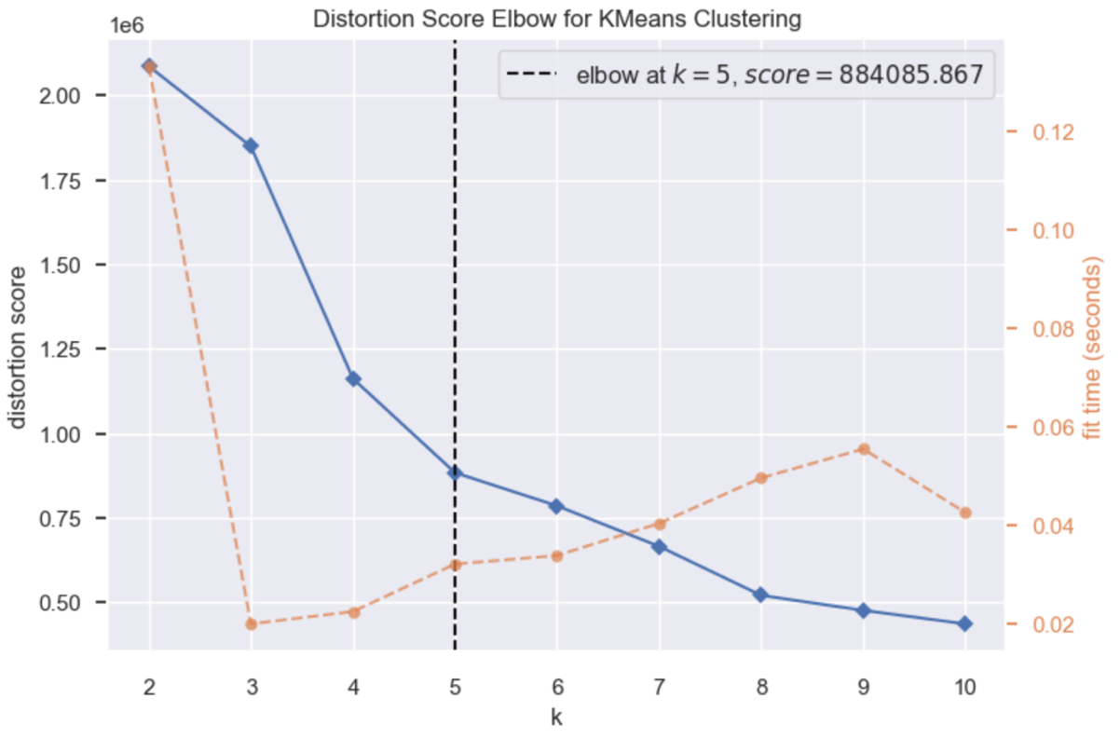

Figure 57: Elbow Method

## Silhouette Score

My elbow method showed 5 to be the best for k, but when running my silhouette score I got results that indicated otherwise. In theory you could go into hundreds of clusters if not more in order to get an optimum silhouette closer to one, but after a certain point the results will just become redundant and impractical for the business to take any action from the insights. With this in mind I decided to fully explore the clustering in my data while keeping to a reasonable range of numbers of clusters of 4 to 12. I created a loop that will run a silhouette score on 4-12 clusters. I will also set the random state to 0 for future replication of the process.

|  |  |
| --- | --- |
| Silhouette Score for 4 clusters | 0.36063281891071836 |
| Silhouette Score for 5 clusters | 0.39232081582862216 |
| Silhouette Score for 6 clusters | 0.3711968097427292 |
| Silhouette Score for 7 clusters | 0.384721207737656 |
| Silhouette Score for 8 clusters | 0.42511132144901764 |
| Silhouette Score for 9 clusters | 0.38162718184276173 |
| Silhouette Score for 10 clusters | 0.3777018003592016 |
| Silhouette Score for 11 clusters | 0.4114949402948788 |
| Silhouette Score for 12 clusters | 0.4041694138446294 |

Table 15: Silhouette Score Table

From these results in table 15, I plotted a very basic line plot with circular markers, visualising the cluster amounts compared to their silhouette scores. As you can see from fig 58, 8 clusters seems to be the best performer out of the range that I chose.

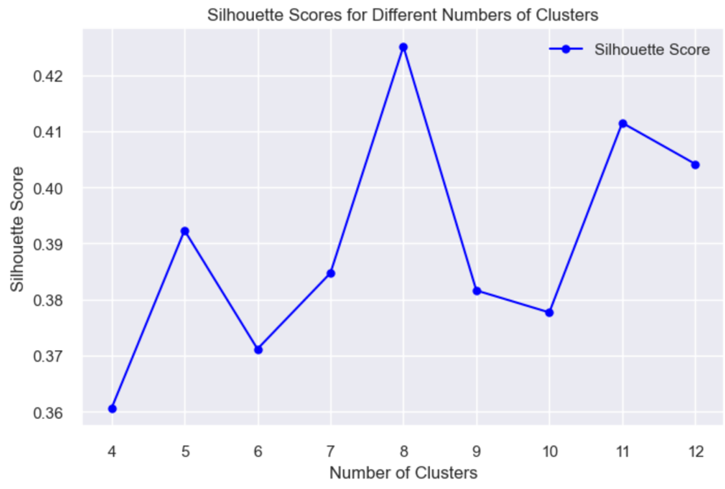

Figure 58: Silhouette Score Graph

## K-Means

I then used the results from the previous step in my KMeans algorithm to cluster my PCA-transformed dataset into 8 clusters, setting the random state to 0 for consistent results in future recreations of the project. I then fit the model to the data and predicted the cluster assignments. The predicted cluster labels are added as a new column called “Clusters” in both the PCA_ds and the original df_2 to show each sample’s cluster membership. I then plotted out an Interactive Plot of the Clusters which you can see in figure 59.

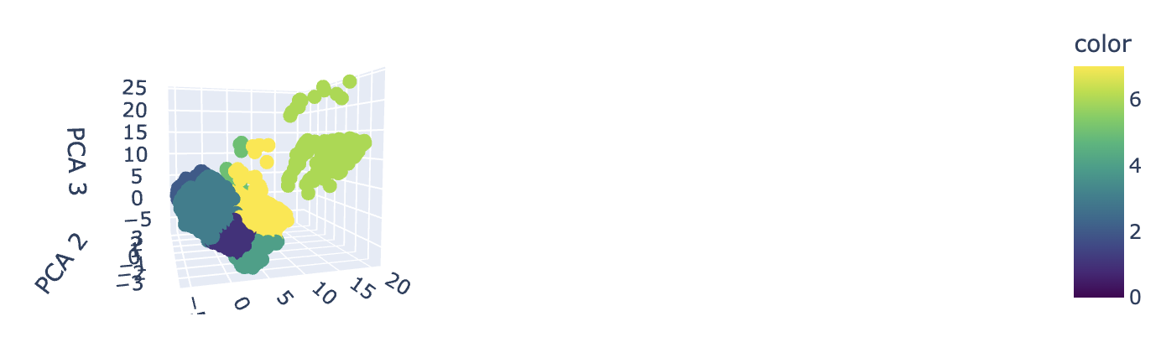

Figure 59: Interactive Plot of the Clusters

## Cluster Analysis

For my Cluster Analysis I decided to analyse my customer segments based off of 3 main characteristics with 6 visualisations. The characteristics will be spending behaviour which will have three plots. The first is comparing order_item_quantities which is how many items are ordered in each transaction and sales_per_customer which is total sales per customer made per customer. The second is comparing order_profit_per_order which is how much profit was earned per order and sales_per_customer. The third is sales_ per_customer and order_item_product_price, which is the price of products without discount. The next characteristic will be time, and will be visualised by comparing shipping_date to sales_per_customer to track spending behaviour throughout the timeline of the data. And finally is geographical, where I will plot sales_per_customer by both longitude and latitude

I started with a bar chart to show the distribution of the 8 clusters in figure 60. Cluster 3 has the highest count with just under 60,000 data points. Clusters 2 and 1 then follow with each having around 40,000 and 30,000 data points. Then, clusters 0, 4, 5, 6, and 7 have quite a lot less data points, with cluster 6 having the smallest amount. This distribution shows that certain clusters are dominating the dataset, while the others represent smaller, more specific segments. This imbalance could be a sign of variations in customer behaviours or characteristics that could use further investigation.

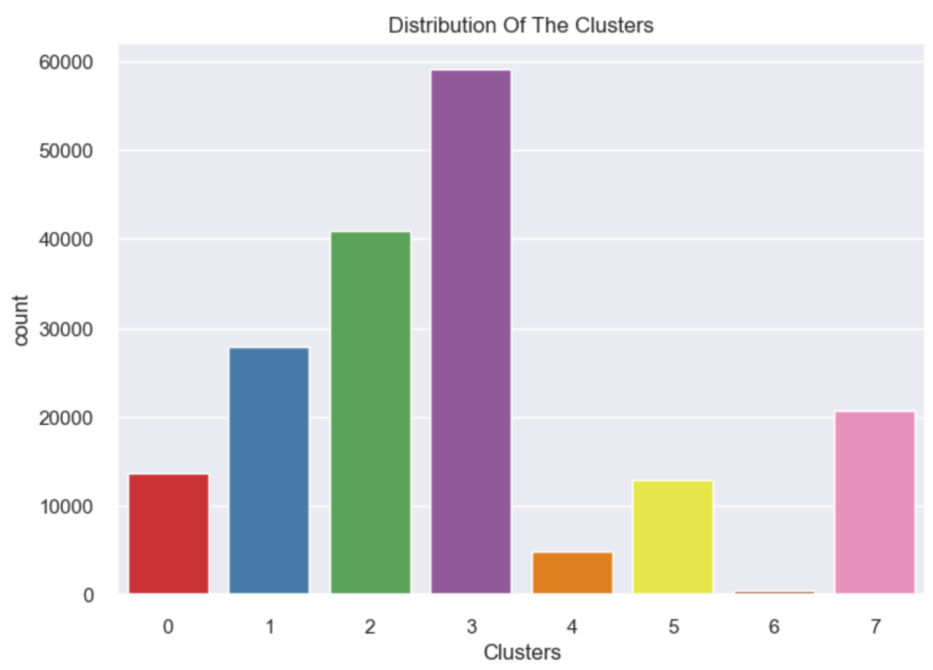

Figure 60: Distribution of Clusters

In figure 61 we see that Cluster 6 (brown) stands out with higher sales per customer, reaching over 1,500, meaning a group of high-spending customers. Clusters 0 (red), 1 (blue), 2 (green), and 3 (purple) are mainly around the lower sales ranges (0–500) with smaller order quantities, meaning more moderate-spending customers.

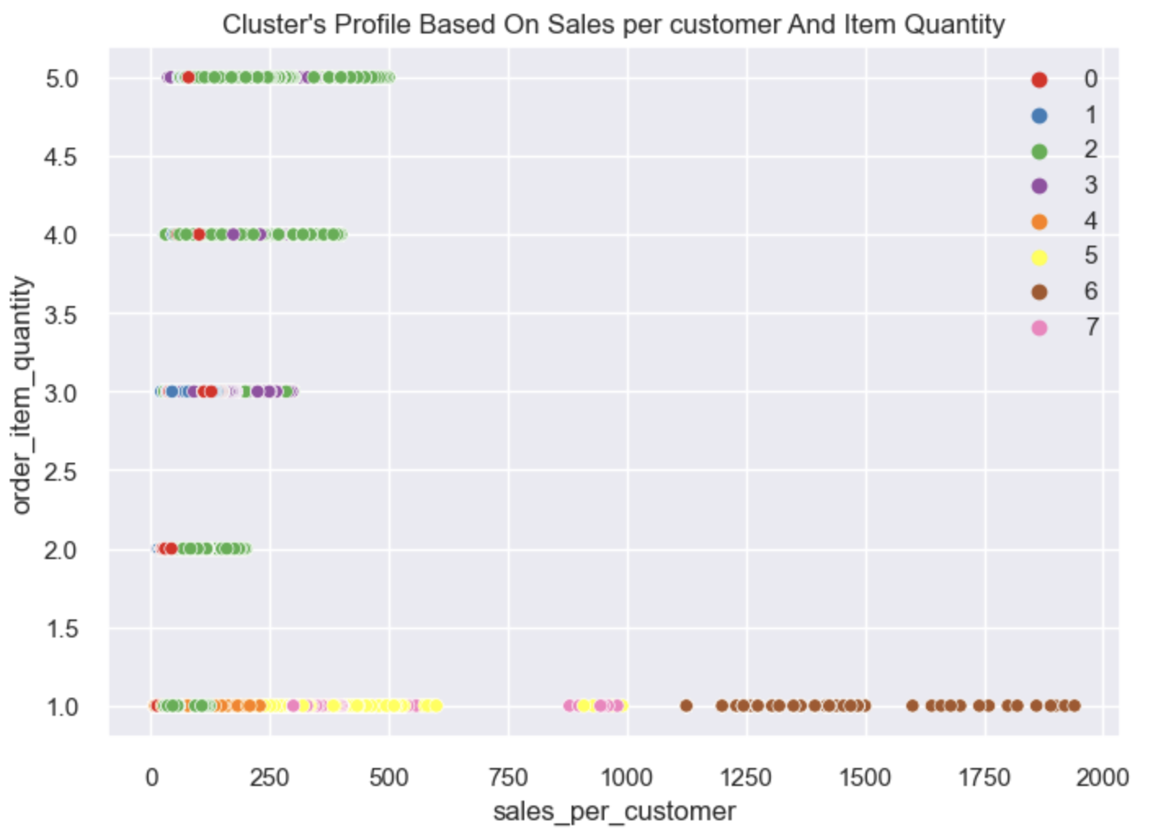

Figure 61: Cluster's Profile Based On Sales per customer And Item Quantity

In figure 62 Cluster 6 (brown) dominates the higher sales per customer range (1,000+), with most of its orders showing positive profits. In contrast then, Clusters 0 (red), 2 (green), and 3 (purple) are mainly concentrated in the lower sales range (0–500), with most orders showing negative profits, indicating potential losses. Cluster 7 (pink) has a few scattered points but shows low sales and mixed profitability.

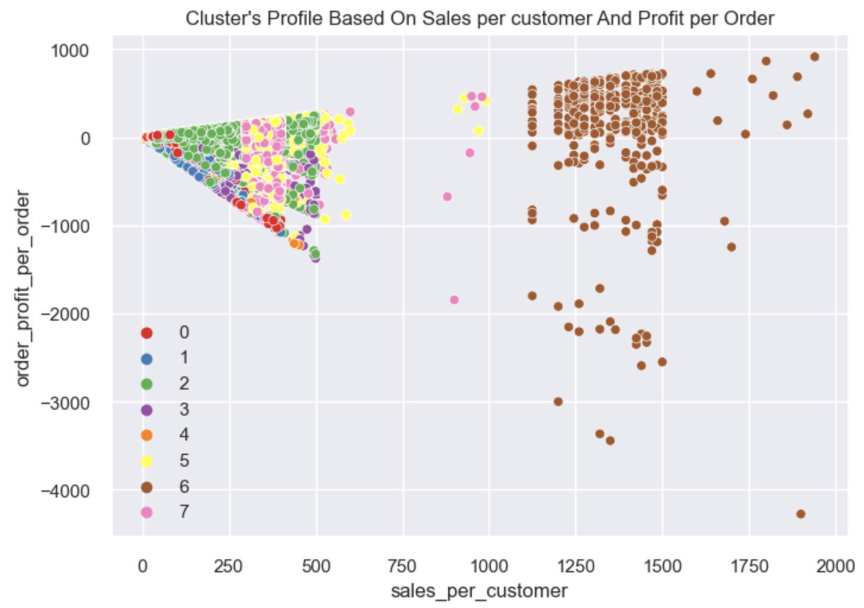

Figure 62: Cluster's Profile Based On Sales per customer And Profit per Order

In figure 63, Cluster 6 (brown) again stands out, showing high-value products with the highest order item product prices, over 1,500, and sales per customer reaching nearly 2,000. Clusters 0 (red), 2 (green), and 3 (purple) stay at lower price levels (0–250) and smaller sales per customer, indicating lower-value products and more modest spending patterns. Clusters 5 (yellow) and 7 (pink) show moderate product prices and sales, sitting between these extremes.

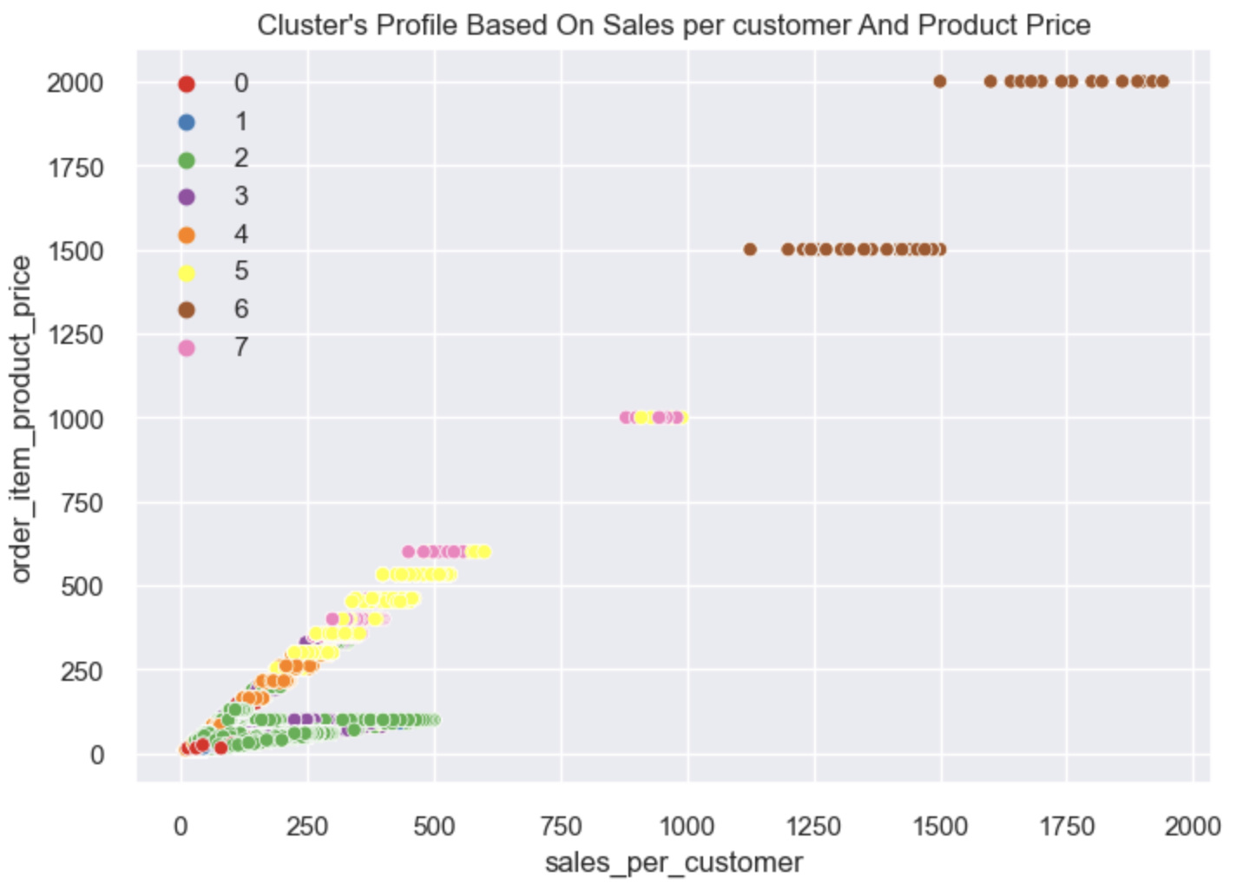

Figure 63: Cluster's Profile Based On Sales per customer And Product Price

Figure 64 just shows us that all clusters consistently buy with us from the beginning of the data timeline to the end. With some notable spikes in Cluster 6 (brown) between shipping_date units 10000 – 22500, which is between 10/25/2016 12:54 & 12/5/2017 3:45. We can get these dates by reversing the label encoder (fig 65).

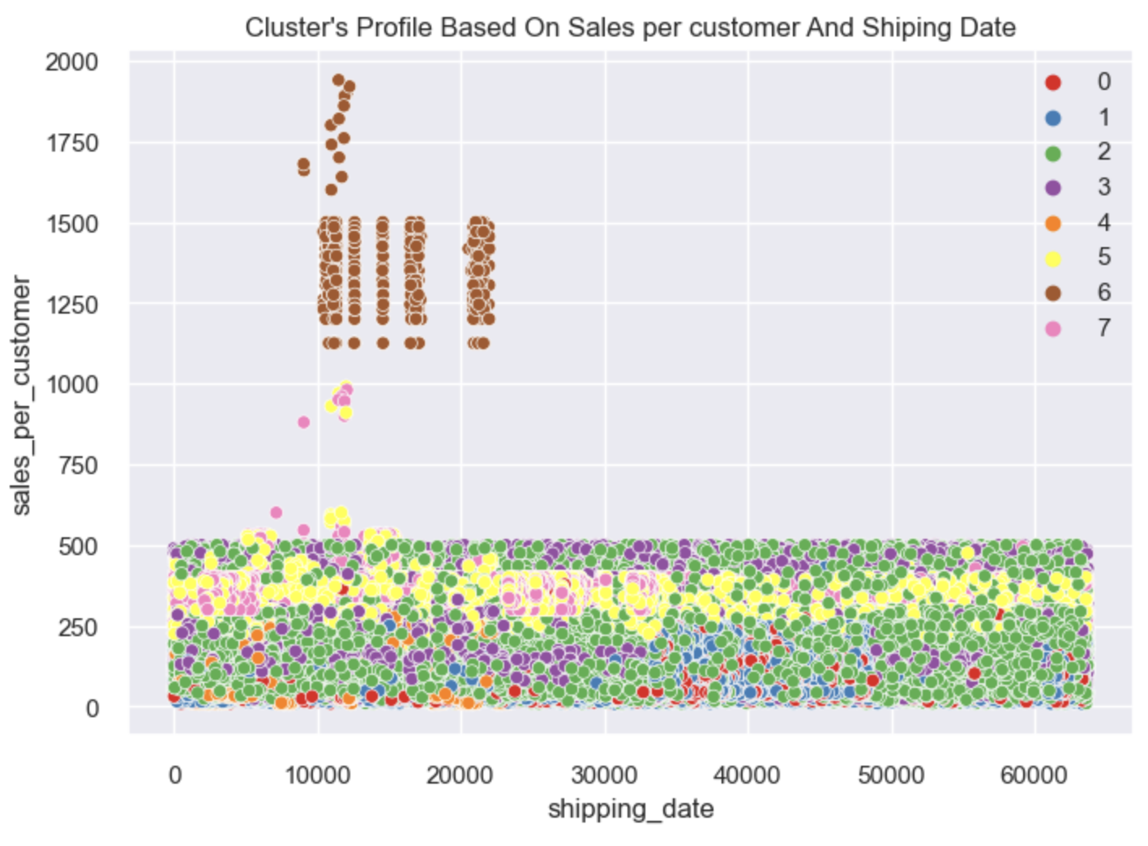

Figure 64: Cluster's Profile Based On Sales per customer And Shipping Date



Figure 65: Shipping date reverse label encoding

Fig 66 and 67 tell us that the majority of our customers are based in the northern hemisphere and the majority of our customers are in the Americas (Specifically North America when combined with latitude).

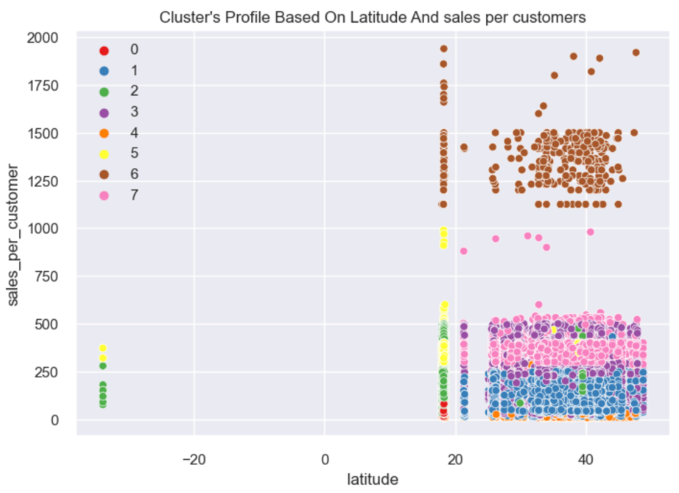

Figure 66: Cluster's Profile Based On Latitude And sales per customers

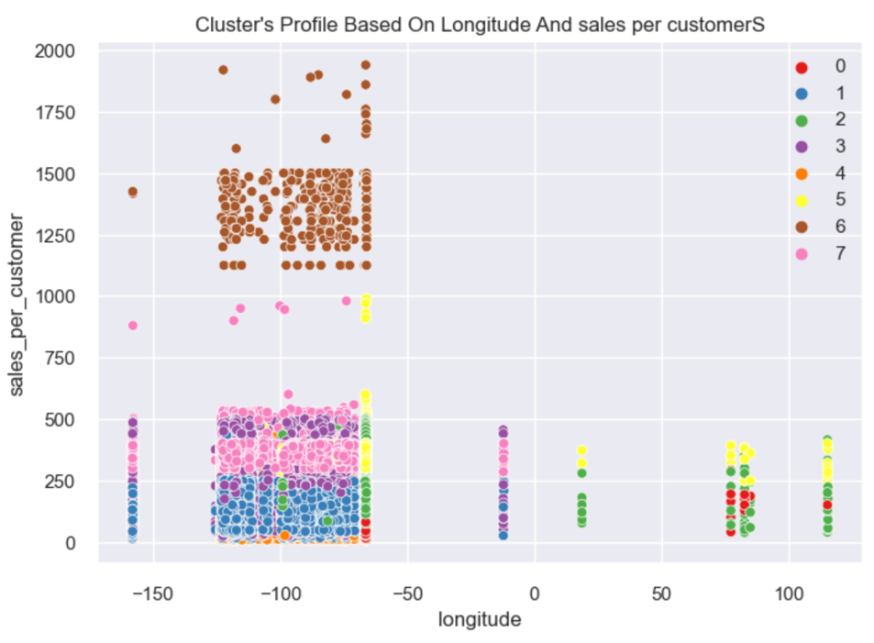

Figure 67: Cluster's Profile Based On Longitude And sales per customers

To summarise only the key finding for the 8 clusters you can see these findings show opportunities for targeted strategies, maximizing value from high-profit clusters like 6, while at the same time nurturing mid-range clusters and boosting profitability in the low-value segments too:

* Cluster 6 is the clear high-value group, with high spending and profitability, making it a key segment for business focus.
* Clusters 0, 2, and 3 represent low-value customers who could benefit from strategies to increase profitability or minimize costs.
* Cluster 7 shows promise with moderate sales and profitability, making it a potential growth segment.

# Results

## Models + Models compared to CA2

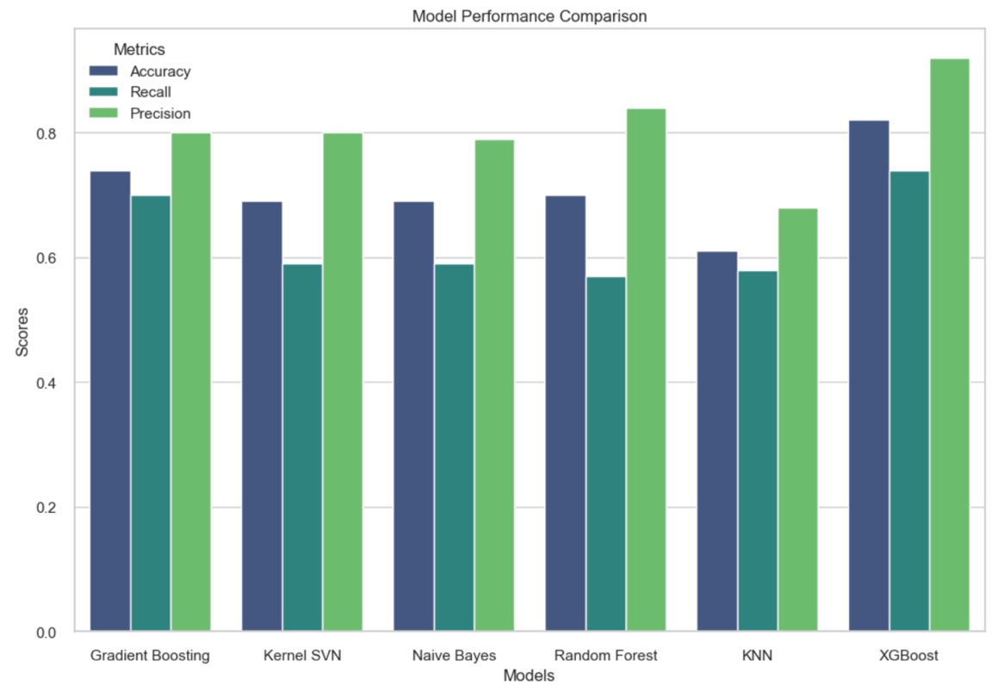

Figure 68: Model performances from CA2 + CA3

In my CA2 I ran three models, Gradient Boosting, Kernel SVN and Naïve Bayes, my top model was the gradient boosting classifier with recall and precision. In my CA3, after running multiple models, I was able to narrow down the top three best performers and then from them I found my best performing model which is the XGBoost model (fig 68). The model performed best on all metrics but still suffers from some slight overfitting, but it’s high recall score and surrounding context as a late delivery predictor definitely gives context to the overfitting. The results showed that shipping_mode is the most influential feature in the outcome of the model by both its high frequency and gain in the feature importances. Some other important features include the days_for_shipment_scheduled, shipping_date, and order_date, which suggests that the aspects of the time of shipping plays a critical role. Features like order_item_id, longitude, market, and customer_city also are important features to the model, but not as much. The LIME analysis shows that specific conditions like a longer scheduled shipment time and certain shipping modes are more likely to prevent late deliveries. This shows the significance of logistical and location features in predicting delivery risk.

A temporary fix that the company can implement today is to just schedule the deliveries later, until the supply chain management team can investigate the logistic and geographic factors to the large amount of late deliveries.

## Customer Segmentations, Insights + Recommendations

In the future I would like to implement a time series analysis to detect fluctuations in shipping demands. I would also like to improve the overfitting on the XGBoost model and experiment with more parameters. I also think using neural networks could yield some interesting results. As well dividing the dataset by locations to try find patterns in certain markets and regions. Although we have successfully found some of the biggest predictors of late deliveries I think rerunning the model without historical features to try and predict weather a delivery will be on time or not ‘live’, could lead to some interesting results too.

Outside of detecting late delivery, I think a market basket analysis of the products could be done on the dataset, as well as a time series of sales.

For our customer segments you could analyse them against many more features, especially with some added feature engineering, to find more interesting correlated features and insights about the groups. I think an exploration of their specific preferred products and buying habits could lead to some actionable insights for the marketing, product and supply chain team.

In terms of limitations, time and hardware and a lack of domain knowledge were the most problematic. With such a large dataset and limited time, I had to run my models on only 50% of the data, which even though they were random sampled and replicable with a consistent random state, is not very ideal. Another limitation is my access to computing power which limited my scope in terms of model selection and implementation. Finally, a lack of domain knowledge in the field has held me back in terms of more specific analysis, and it would be recommended in the future to seek assistance with an expert in either the retail or logistics space, depending on the specific task.

# Conclusion

In conclusion, even with the limitations mentioned previously I was able to create a relatively good model that met the objective of beating out my previous models from my CA2. I was able to find eight distinct customer segments and identify some of their characteristics, and achieve a weak to moderate silhouette score, and I was able to process and conduct in-dept EDA and find insights beyond those found in my CA2. I learned a lot about these models, model interpretability, working with large datasets and working within the boundaries of an Agile Methodology project. All in all, this project has successfully completed it’s objectives.

# References

## Presentation Link -

## Word Count - 5470

1. Aljohani, A. (2023). Predictive Analytics and Machine Learning for Real-Time Supply Chain Risk Mitigation and Agility. Sustainability, 15(20), 15088. Available at: https://doi.org/10.3390/su152015088.
2. Bentéjac, C., Csörgő, A. and Martínez-Muñoz, G. (2020) ‘A comparative analysis of gradient boosting algorithms’, Artificial Intelligence Review, 54(3), pp. 1937–1967. doi:10.1007/s10462-020-09896-5.
3. Breiman, Leo. “Random Forests.” Machine Learning, vol. 45, no. 1, 2001, pp. 5–32, link.springer.com/article/10.1023/a:1010933404324, https://doi.org/10.1023/a:1010933404324. Accessed 24 Sept. 2024.
4. Brownlee, J. (2019). Feature Importance and Feature Selection with XGBoost in Python. Available at: https://machinelearningmastery.com/feature-importance-and-feature-selection-with-xgboost-in-python/ [Accessed 25 Sep. 2024].
5. Chandra, P.L. (2013) ‘Methodological Analysis of Principal Component Analysis (PCA) Method’, M International Journal of Computational Engineering & Management, 16(2), p. 32. Available at: https://citeseerx.ist.psu.edu/document?repid=rep1&type=pdf&doi=6f5c37562374b9053d8212d7c97bbdd68cee2133 (Accessed: 23 May 2024).
6. Chopra, Sunil, and Peter Meindl. Supply Chain Management: Strategy, Planning and Operation. 6th ed., New York, NY, Pearson Education, 2019, p. Chapter 4.3.
7. Constante, Fabian, et al. “DataCo SMART SUPPLY CHAIN for BIG DATA ANALYSIS.” Data.mendeley.com, vol. 5, 12 Mar. 2019, data.mendeley.com/datasets/8gx2fvg2k6/5,https://doi.org/10.17632/8gx2fvg2k6.5.
8. Han, J., Pei, J. and Kamber, M. (2011) Data Mining: Concepts and Techniques, 3rd Edition. Morgan Kaufmann. Chapter 10: Cluster Analysis: Basic Concepts and Methods.
9. James, G., Witten, D., Hastie, T., & Tibshirani, R. (2015). An Introduction to Statistical Learning: With Applications in R. New York: Springer, pp. 128-130.
10. Jolliffe, I.T. and Cadima, J. (2016) ‘Principal component analysis: A review and recent developments’, Philosophical Transactions of the Royal Society A: Mathematical, Physical and Engineering Sciences, 374(2065), p. 20150202. doi:10.1098/rsta.2015.0202.
11. Leino, M. (2016) Coding Standards in Web Development, N/A. Available at: https://www.theseus.fi/bitstream/handle/10024/112473/leino_martti.pdf?sequence=1 (Accessed: 23 May 2024).
12. Müller, A.C. (2016) Introduction to Machine Learning with Python: A Guide for Data Scientists. Sebastopol, CA: O’Reilly Media, Inc.
13. Ogbuabor, G. and F. N, U. (2018) ‘Clustering algorithm for a healthcare dataset using silhouette score value’, International Journal of Computer Science and Information Technology, 10(2), pp. 32–35. doi:10.5121/ijcsit.2018.10203.
14. Scikit-learnCV. (2023). Cross-validation: evaluating estimator performance. Available at: https://scikit-learn.org/stable/modules/cross_validation.html [Accessed 25 Sep. 2024].
15. Scikit-learnKNN. (2024). KNeighborsClassifier. Available at: https://scikit-learn.org/stable/modules/generated/sklearn.neighbors.KNeighborsClassifier.html [Accessed 25 Sep. 2024].
16. Scikit-learnLE. (2023). LabelEncoder. Available at: https://scikit-learn.org/stable/modules/generated/sklearn.preprocessing.LabelEncoder.html [Accessed 25 Sep. 2024].
17. Scikit-learnRF. (2024). RandomForestClassifier. Available at: https://scikit-learn.org/stable/modules/generated/sklearn.ensemble.RandomForestClassifier.html [Accessed 25 Sep. 2024].
18. Sinaga, K.P. and Yang, M.-S. (2020) ‘Unsupervised K-means clustering algorithm’, IEEE Access, 8, pp. 80716–80727. doi:10.1109/access.2020.2988796.
19. SupplyChainBrain. (2023). How Predictive Analytics Can Help Supply Chains to Thrive. SupplyChainBrain. Available at: https://www.supplychainbrain.com/articles/35396-how-predictive-analytics-can-help-supply-chains-to-thrive.
20. W3Schools Online Web Tutorials. Available at: https://www.w3schools.com/html/html_page_title.asp (Accessed: 15 October 2024).
21. Zelkowitz, M.V. (2002). ‘Chapter 2’. In: Advances in Computers, vol. 62, London: Academic Press, p. 12.